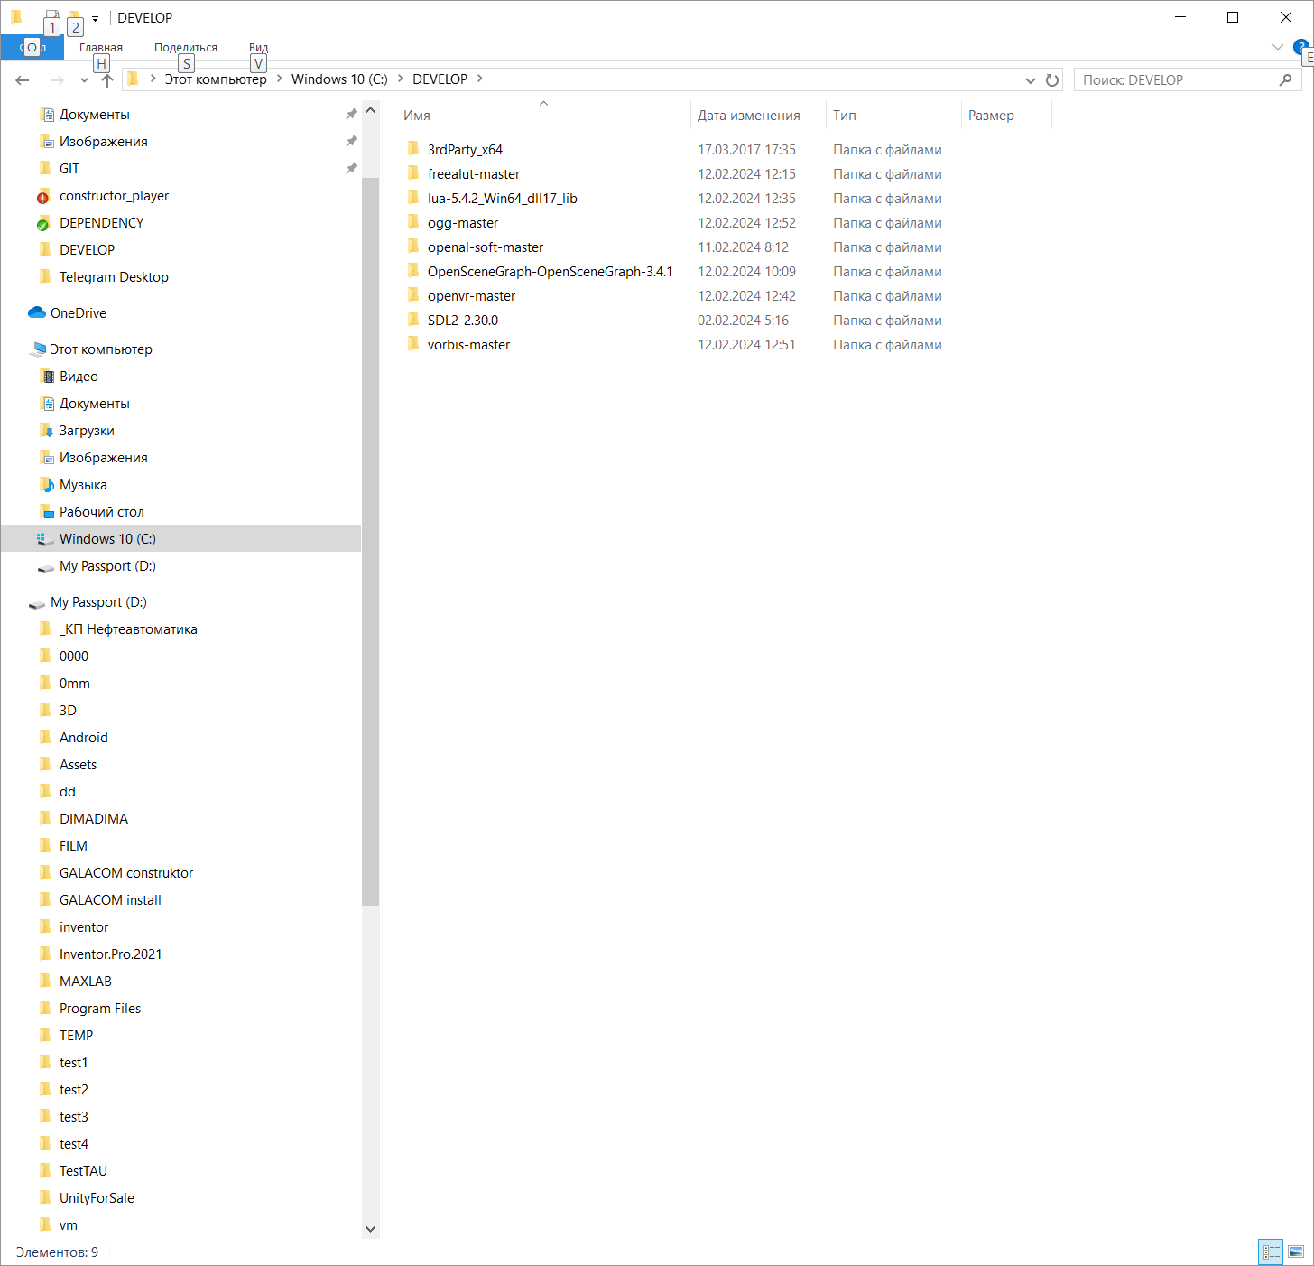

Каталог для сборки дополнительных библиотек (из codct\constructor_player\DEPENDENCY)

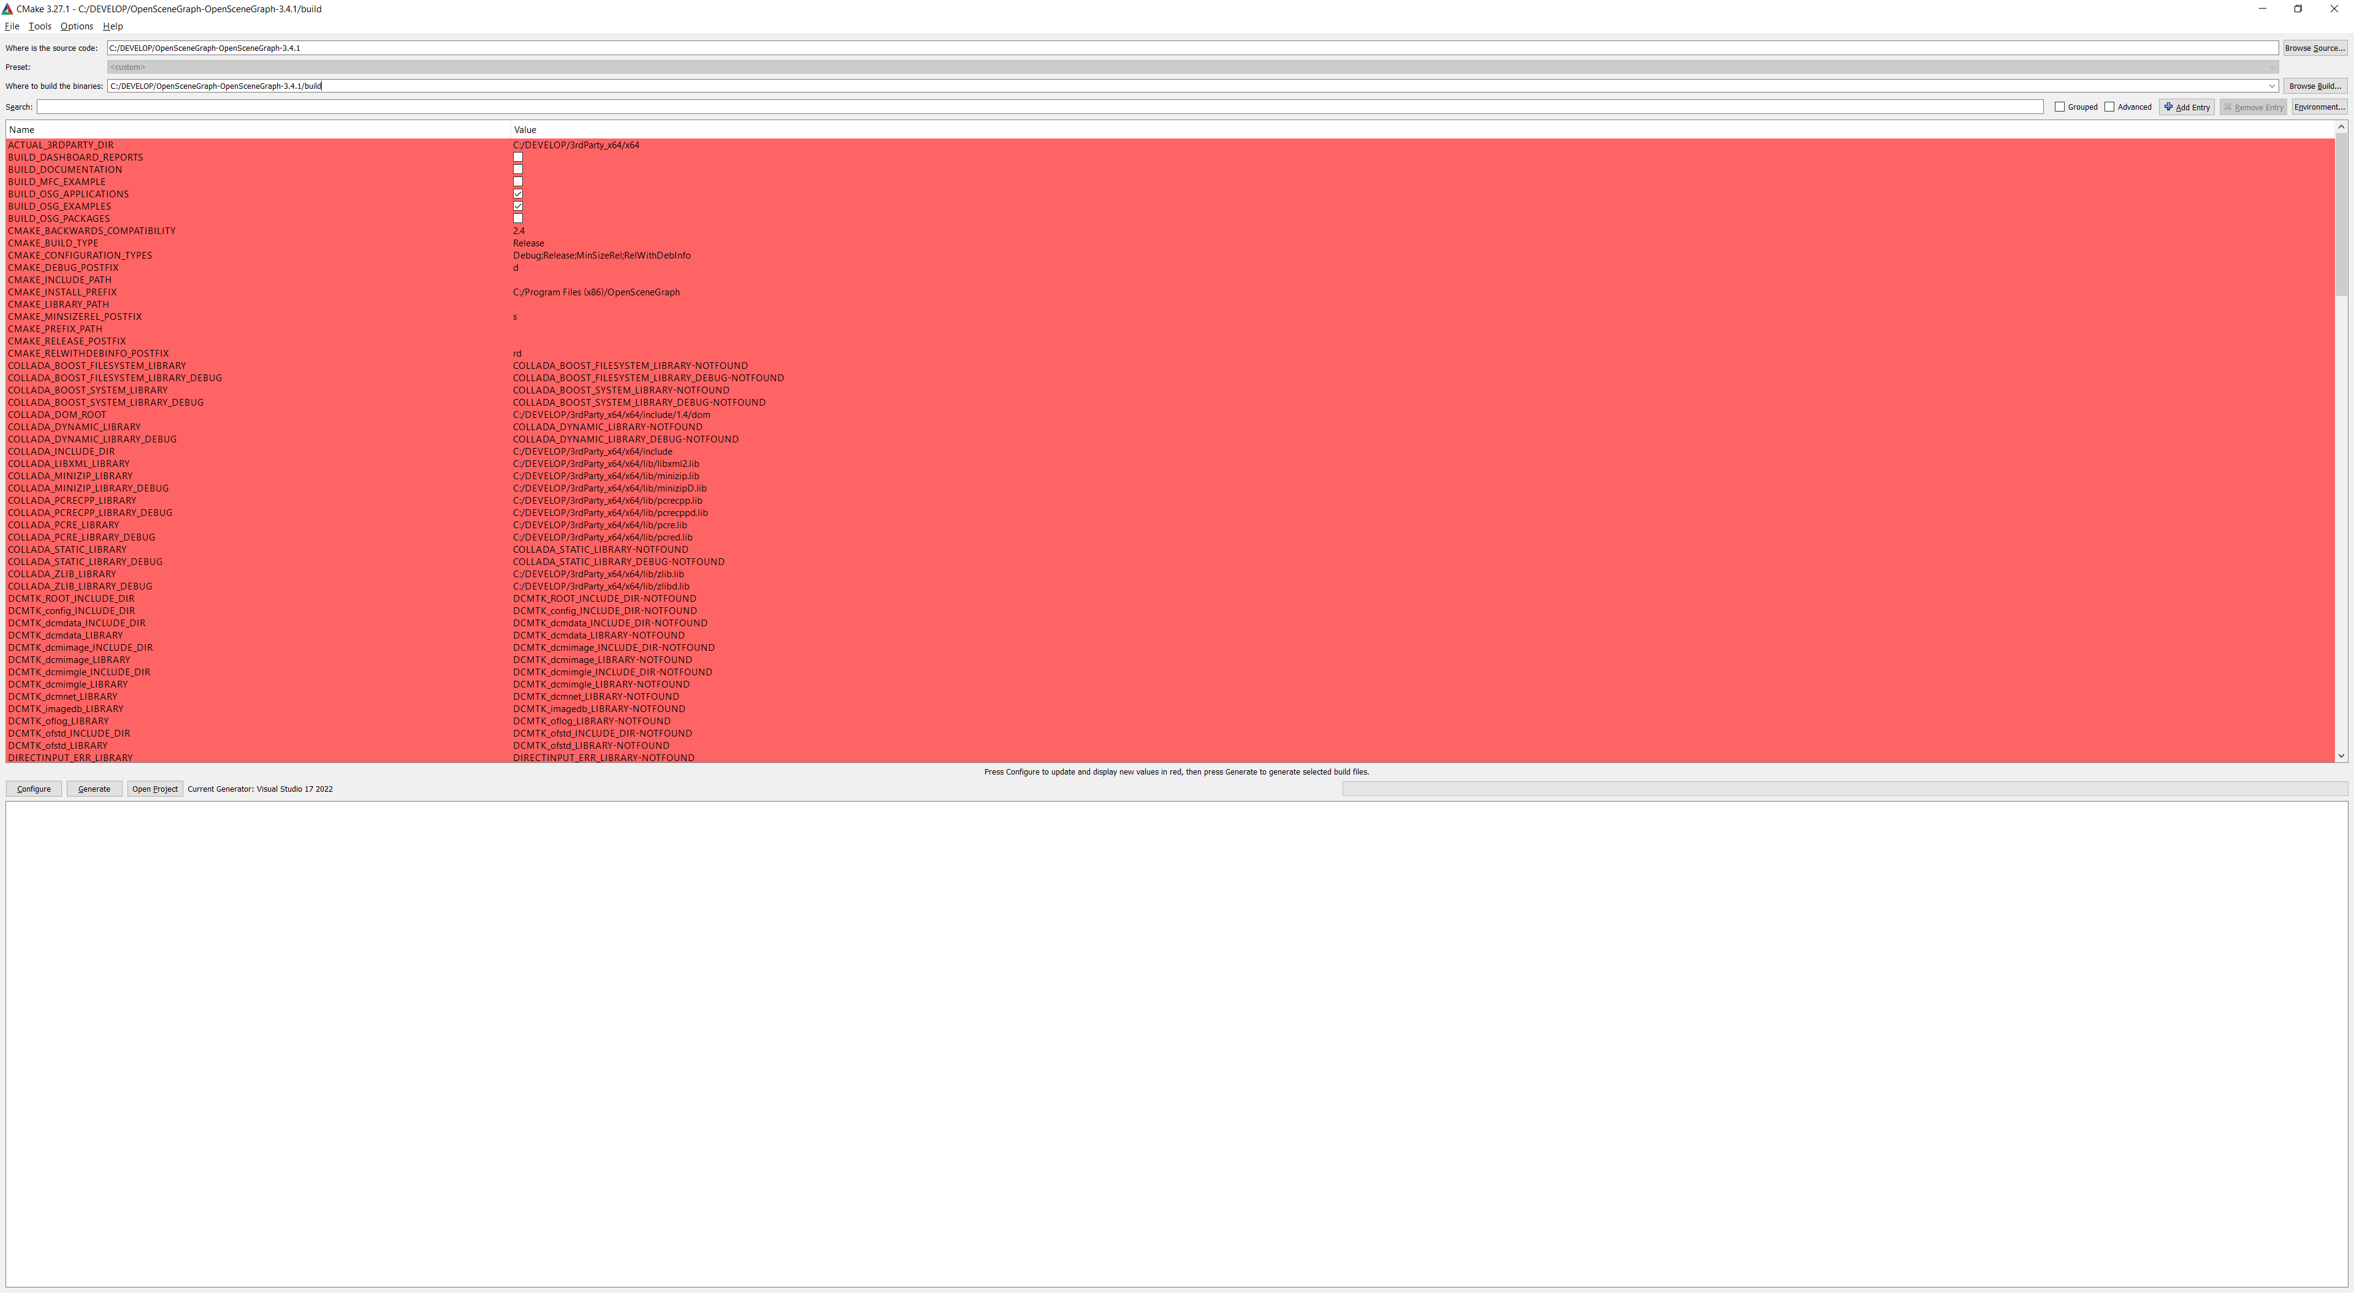

Настройки CMake для сборки C:/DEVELOP/OpenSceneGraph-OpenSceneGraph-3.4.1

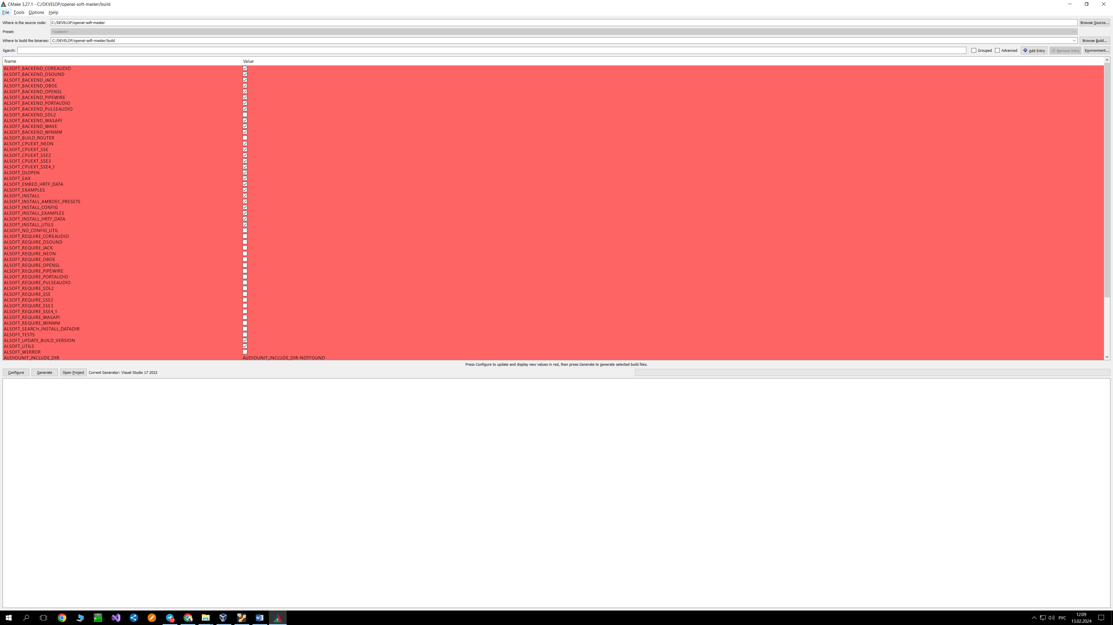

Настройки CMake для сборки C:/DEVELOP/openal-soft-master

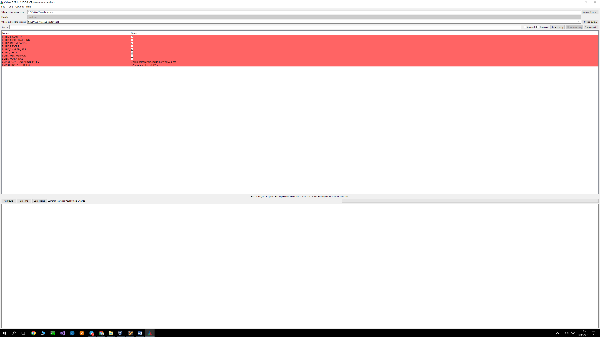

C:/DEVELOP/freealut-master

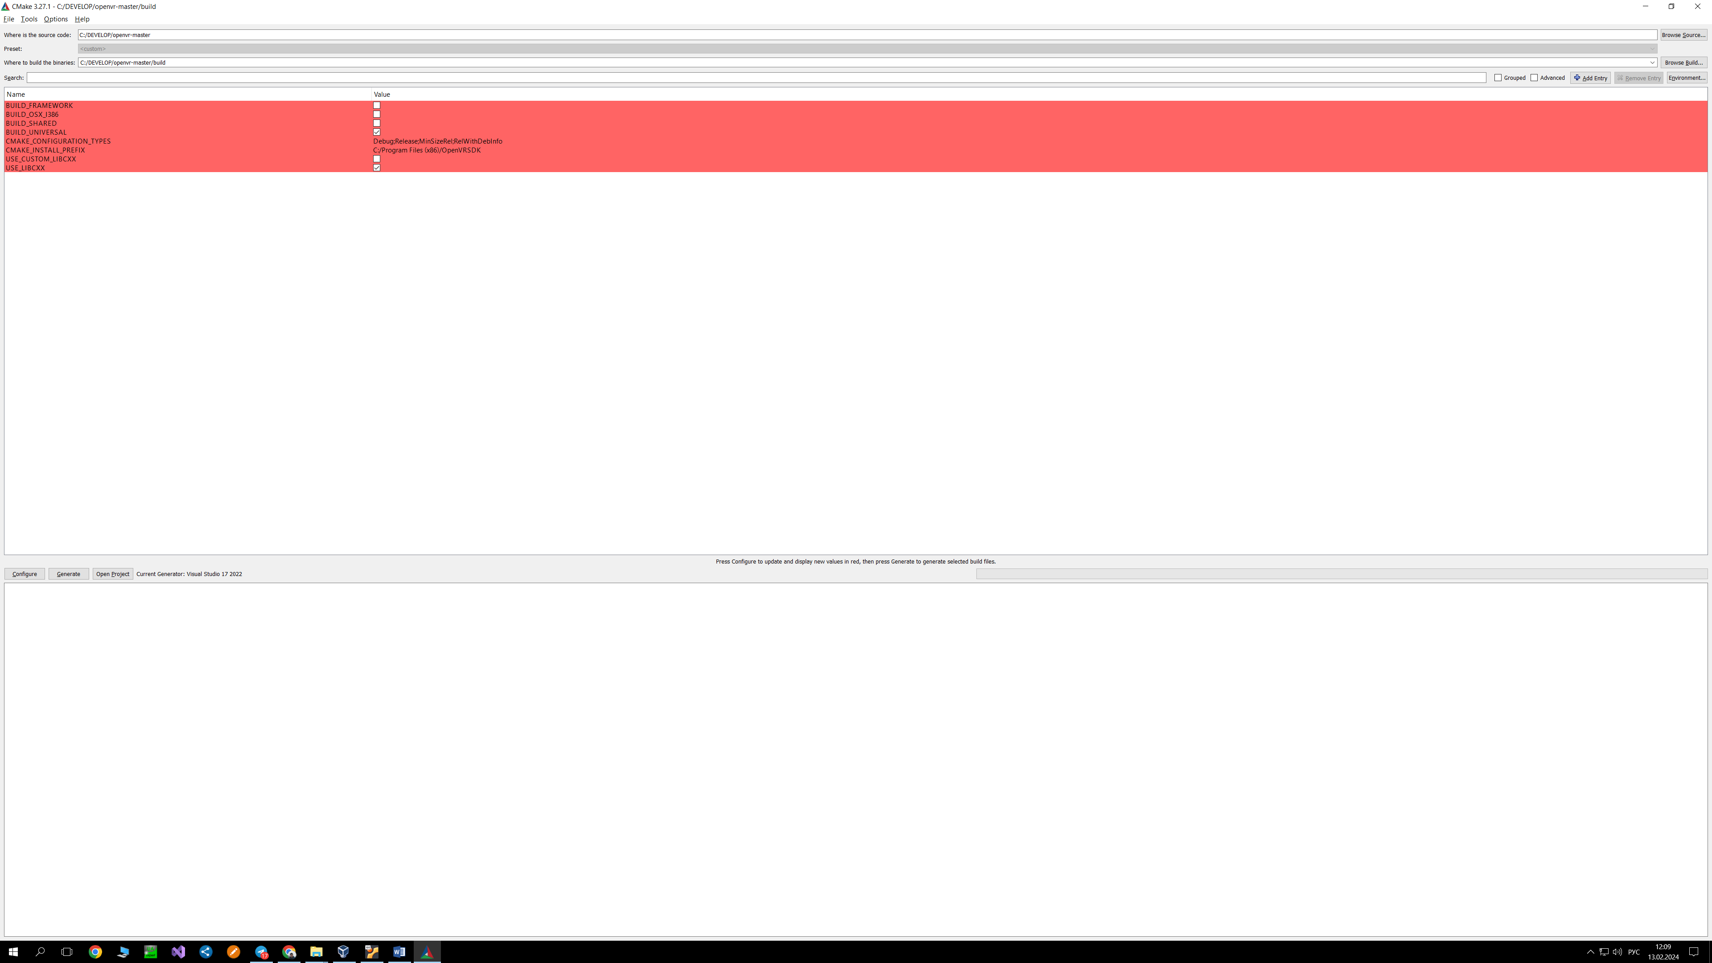

C:/DEVELOP/openvr-master

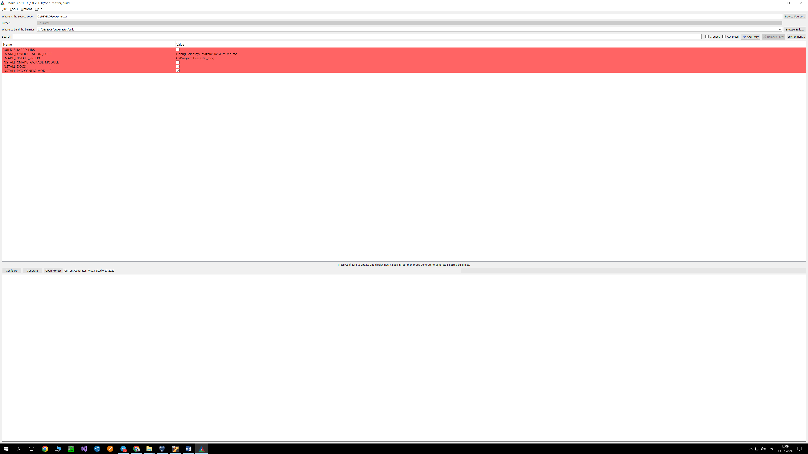

C:/DEVELOP/ogg-master

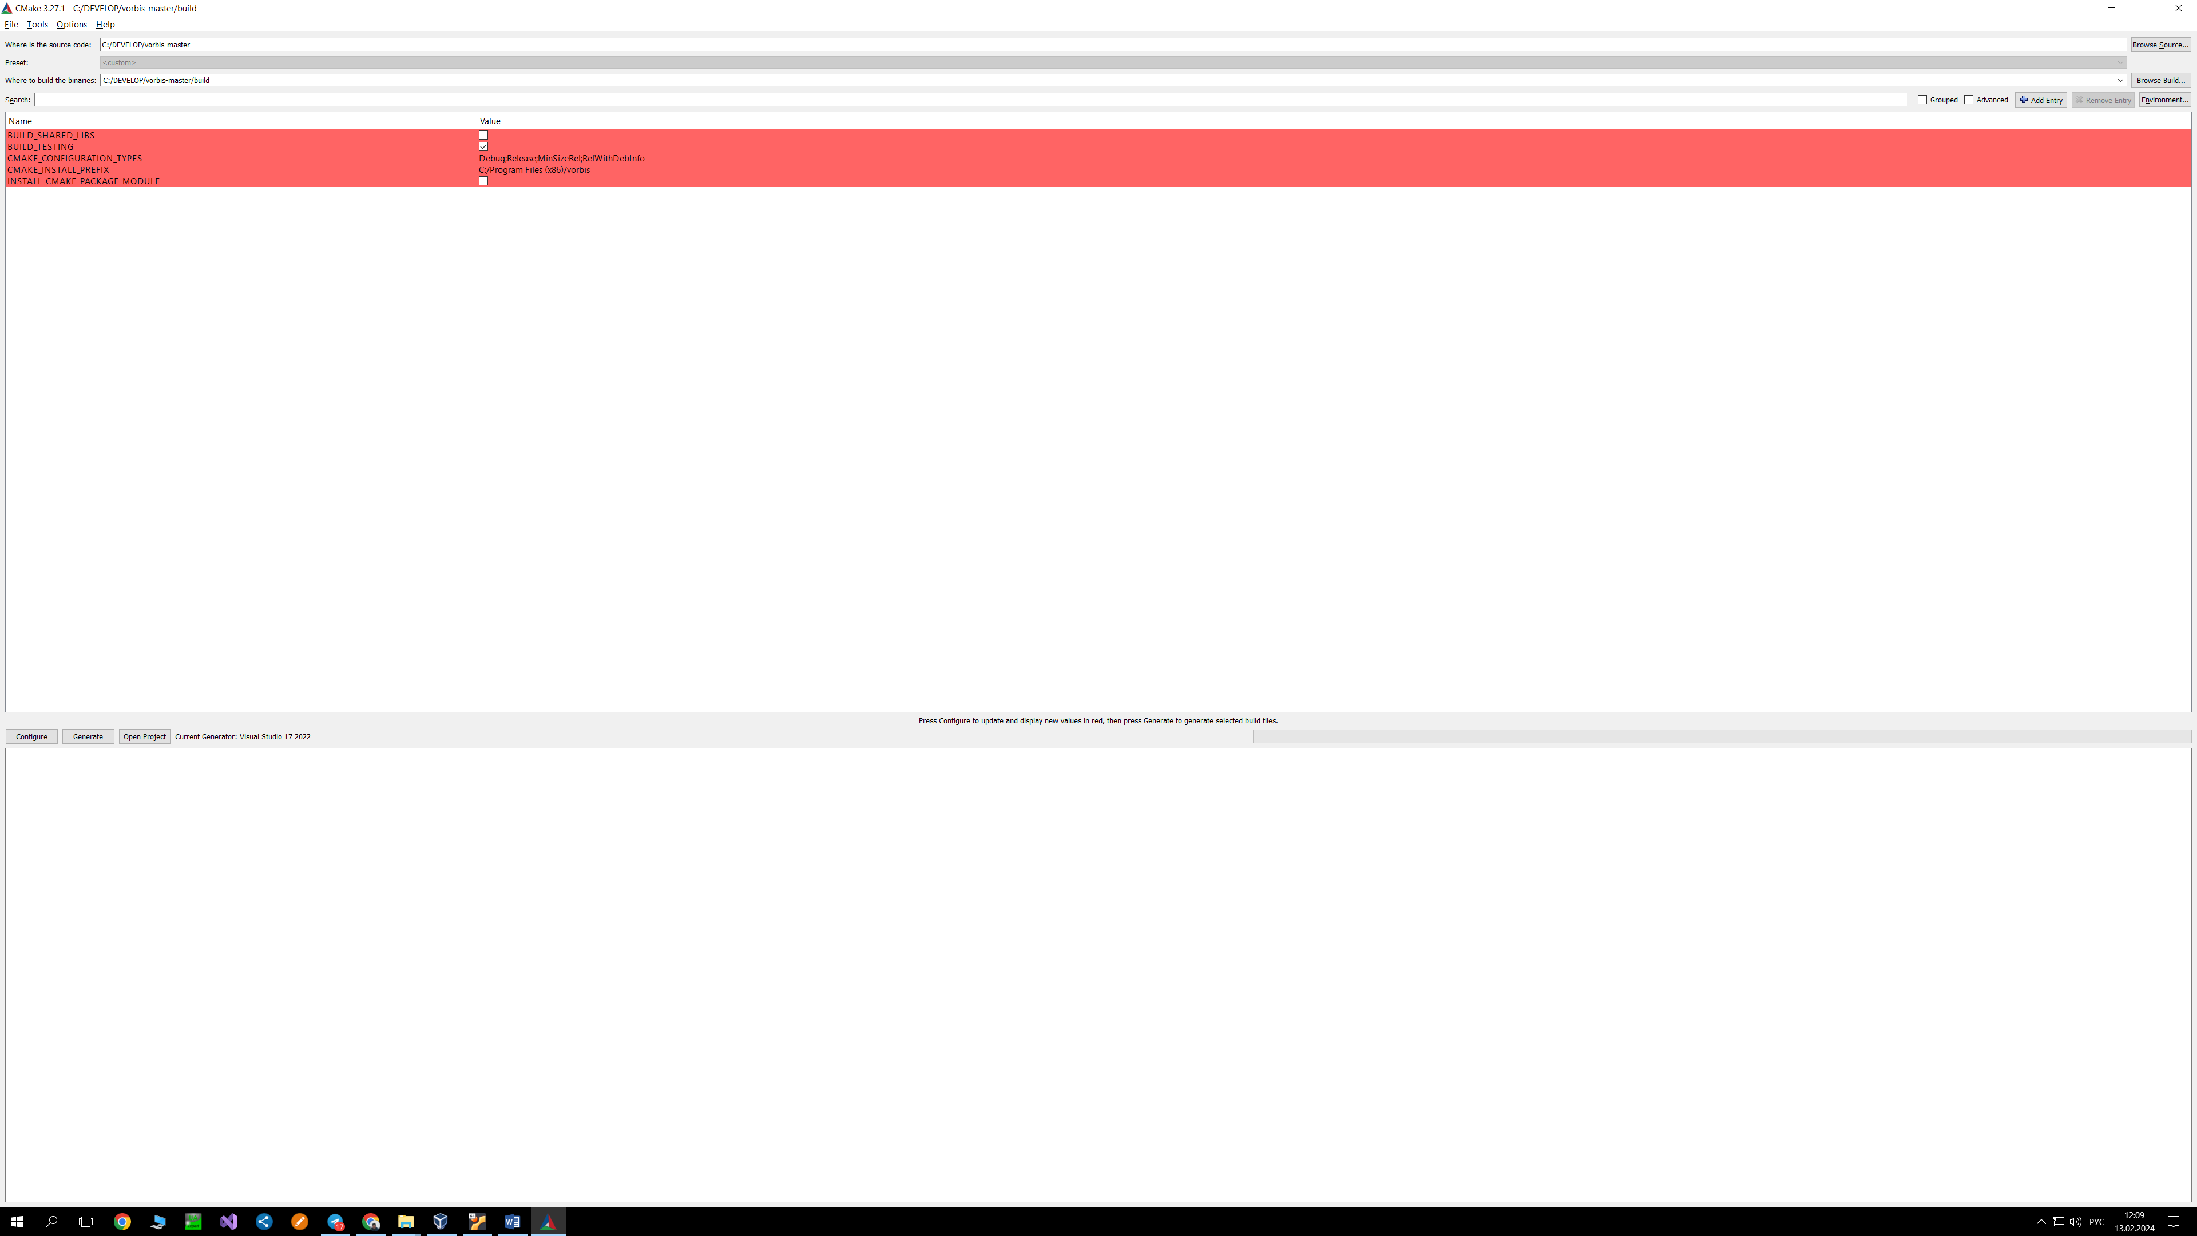

C:/DEVELOP/vorbis-master

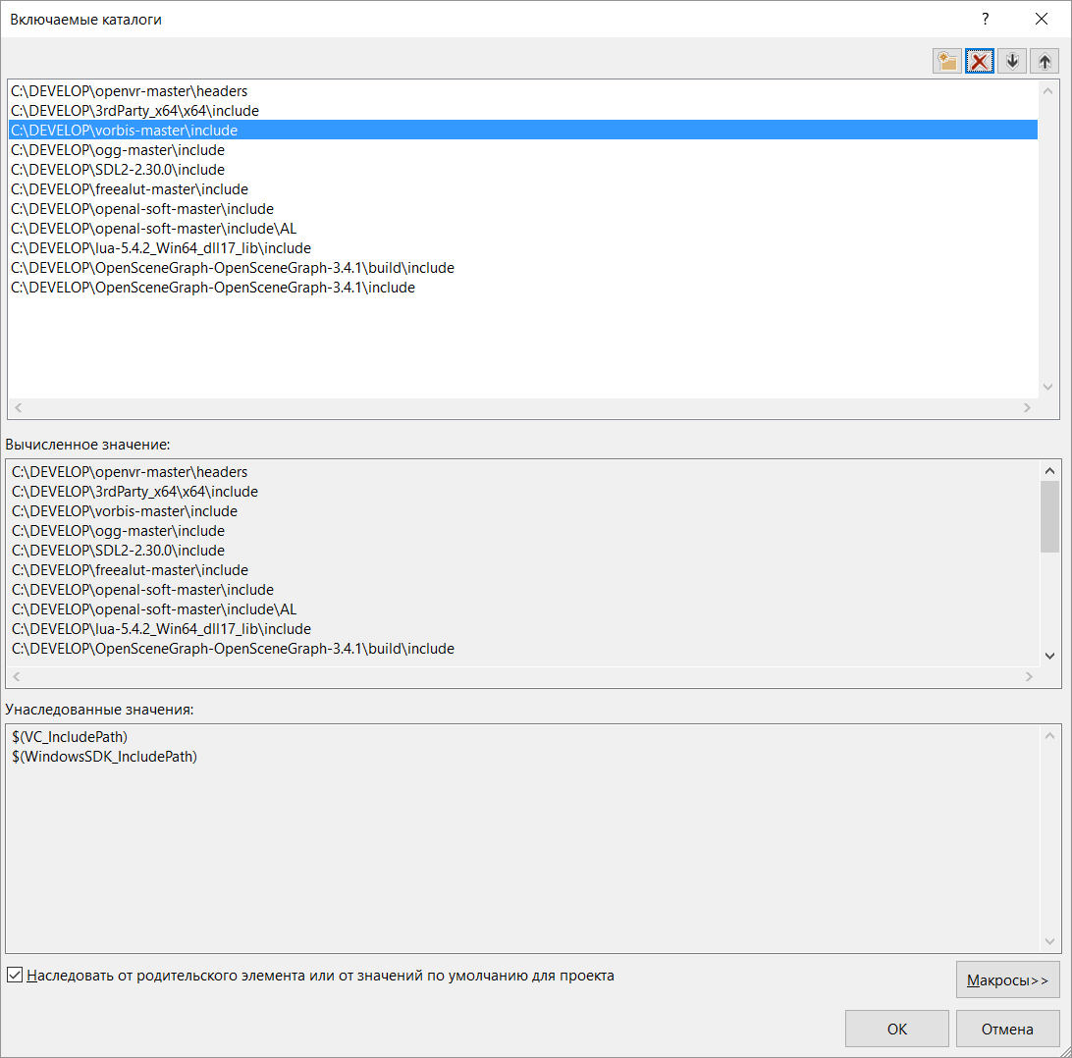

Подключаемые каталоги библиотек для компилятора

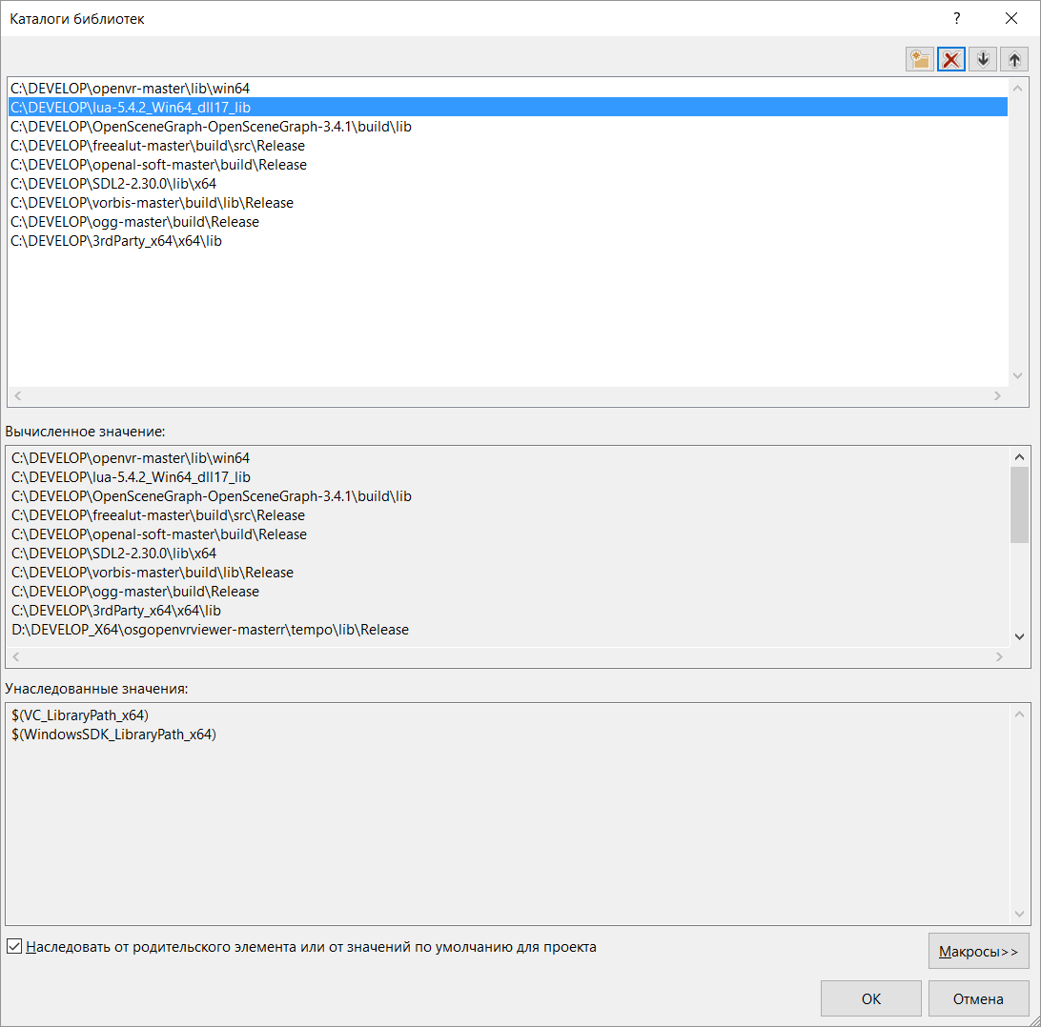

Подключаемые каталоги библиотек для линковщика

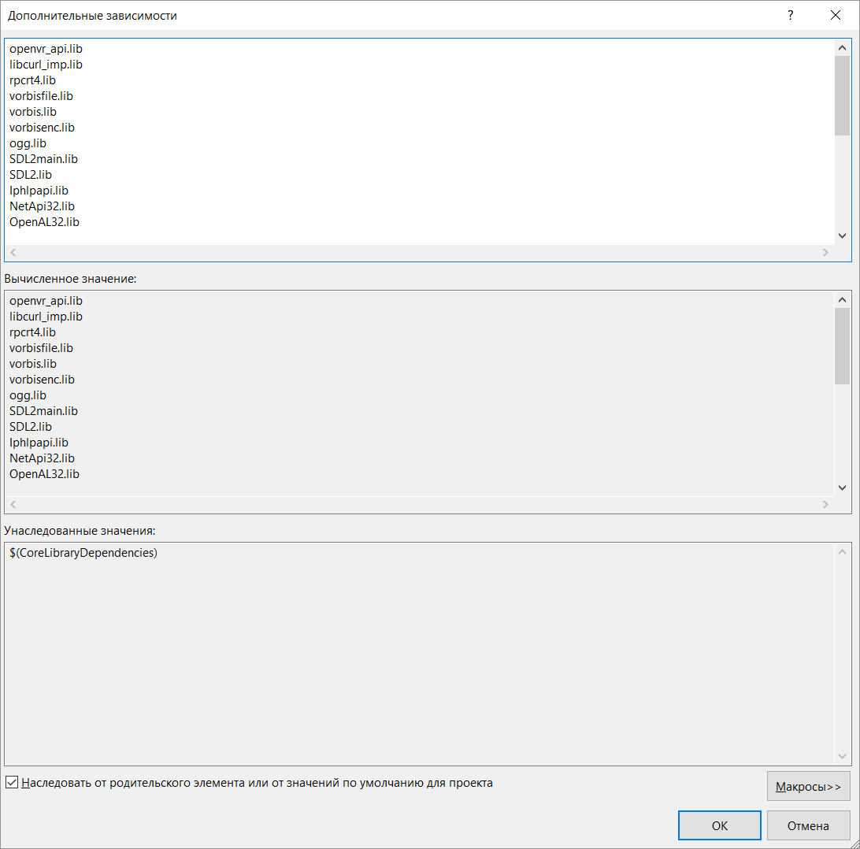

Используемые библиотеки для линковщика

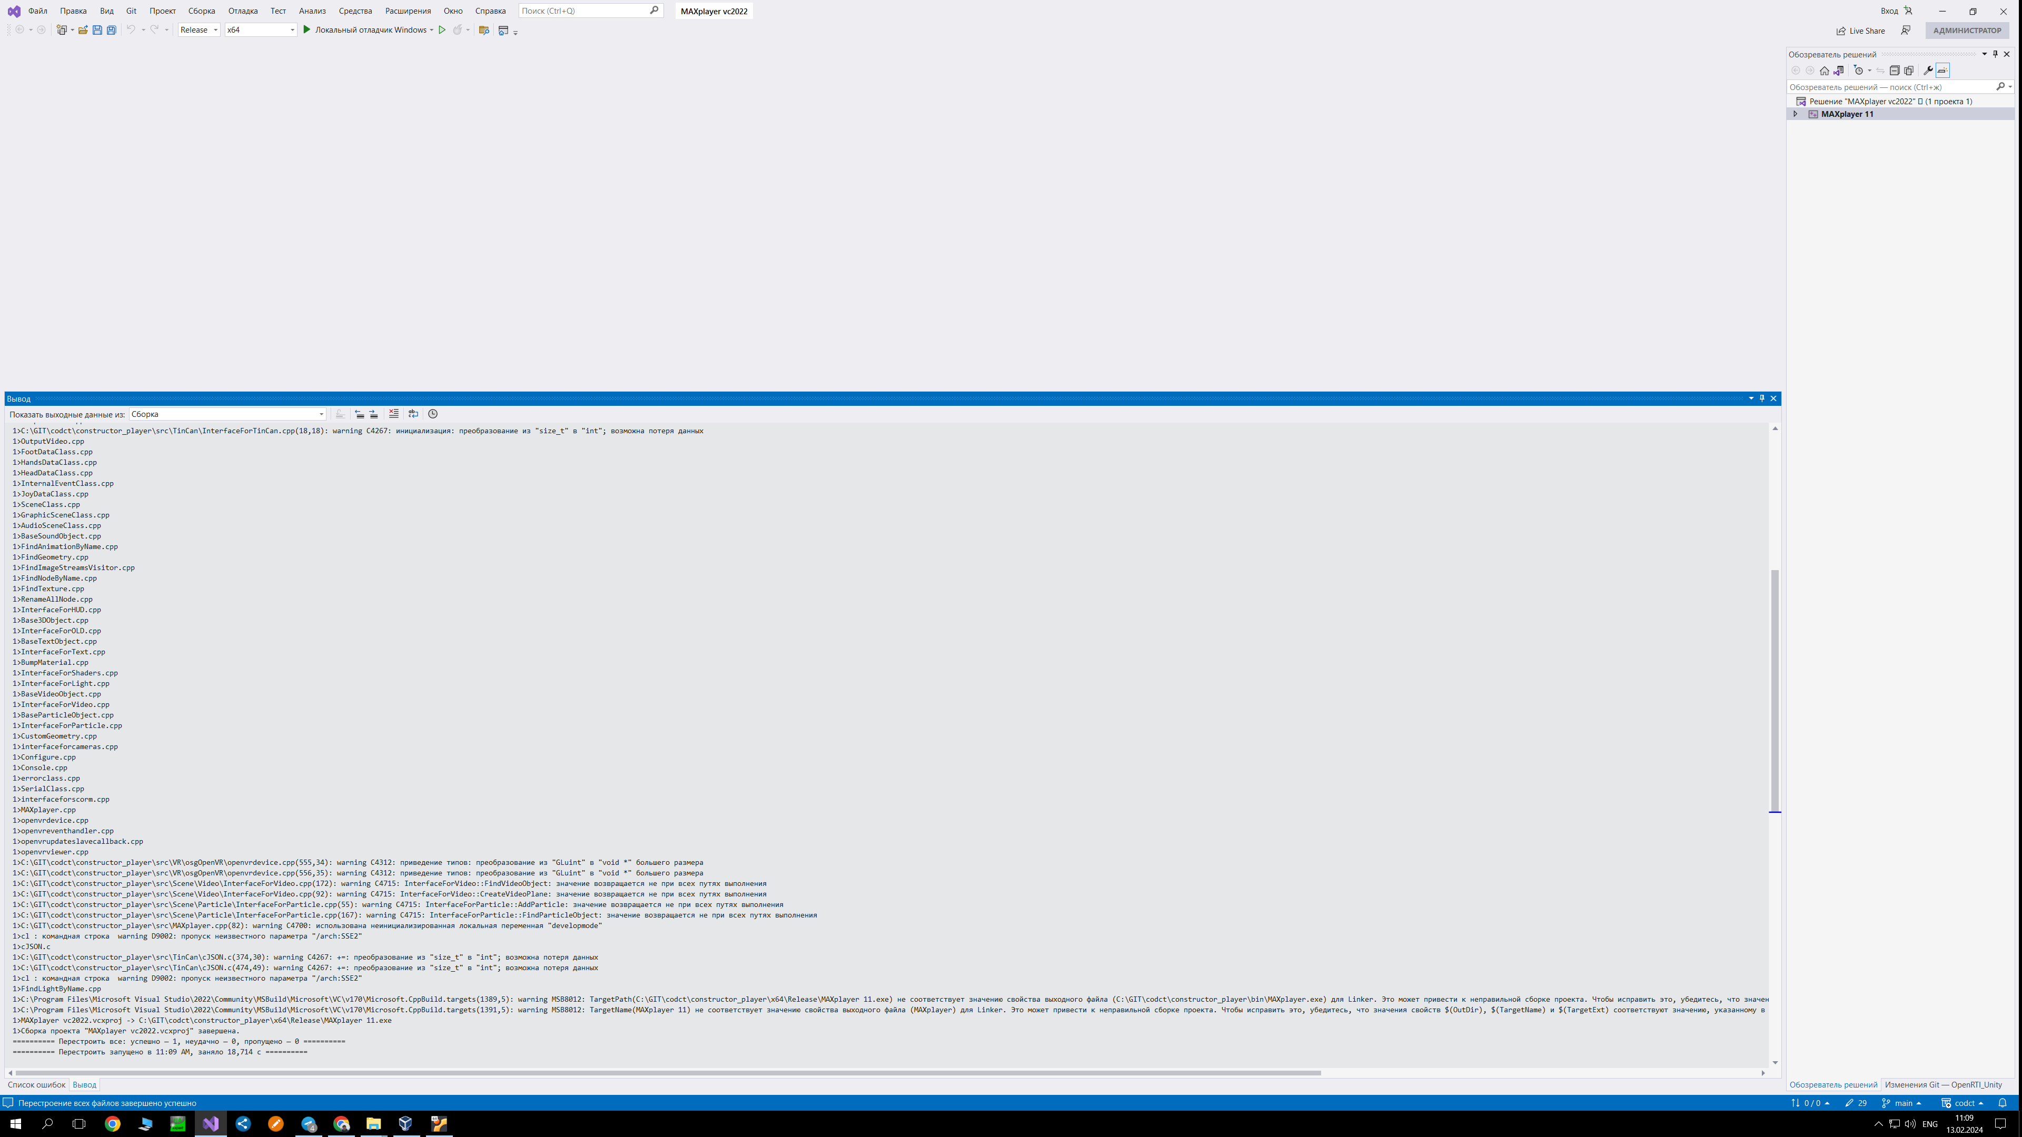

Сборка в windows на MS Visual Studio 2022 x64

Лог сборки:

Повторная сборка начата…

1>------ Перестроение всех файлов начато: проект: MAXplayer 11, Конфигурация: Release x64 ------

1>cl : командная строка warning D9002: пропуск неизвестного параметра "/arch:SSE2"

1>cl : командная строка warning D9002: пропуск неизвестного параметра "/arch:SSE2"

1>interface_for_skin_animation.cpp

1>cl : командная строка warning D9002: пропуск неизвестного параметра "/arch:SSE2"

1>cl : командная строка warning D9002: пропуск неизвестного параметра "/arch:SSE2"

1>cl : командная строка warning D9002: пропуск неизвестного параметра "/arch:SSE2"

1>skin_animation_manager.cpp

1>ChangeShaderUniformVisitor.cpp

1>ffssao.cpp

1>cl : командная строка warning D9002: пропуск неизвестного параметра "/arch:SSE2"

1>cl : командная строка warning D9002: пропуск неизвестного параметра "/arch:SSE2"

1>cl : командная строка warning D9002: пропуск неизвестного параметра "/arch:SSE2"

1>cl : командная строка warning D9002: пропуск неизвестного параметра "/arch:SSE2"

1>InterfaceForTinCan.cpp

1>cl : командная строка warning D9002: пропуск неизвестного параметра "/arch:SSE2"

1>User.cpp

1>cl : командная строка warning D9002: пропуск неизвестного параметра "/arch:SSE2"

1>cl : командная строка warning D9002: пропуск неизвестного параметра "/arch:SSE2"

1>cl : командная строка warning D9002: пропуск неизвестного параметра "/arch:SSE2"

1>UserFoot.cpp

1>cl : командная строка warning D9002: пропуск неизвестного параметра "/arch:SSE2"

1>cl : командная строка warning D9002: пропуск неизвестного параметра "/arch:SSE2"

1>UserHands.cpp

1>cl : командная строка warning D9002: пропуск неизвестного параметра "/arch:SSE2"

1>Input.cpp

1>cl : командная строка warning D9002: пропуск неизвестного параметра "/arch:SSE2"

1>InputKeyboard.cpp

1>InputKeys.cpp

1>keytranslation.cpp

1>InputMouse.cpp

1>InputJoystick.cpp

1>Output.cpp

1>OutputAudio.cpp

1>C:\GIT\codct\constructor_player\src\TinCan\InterfaceForTinCan.cpp(18,18): warning C4267: инициализация: преобразование из "size_t" в "int"; возможна потеря данных

1>OutputVideo.cpp

1>FootDataClass.cpp

1>HandsDataClass.cpp

1>HeadDataClass.cpp

1>InternalEventClass.cpp

1>JoyDataClass.cpp

1>SceneClass.cpp

1>GraphicSceneClass.cpp

1>AudioSceneClass.cpp

1>BaseSoundObject.cpp

1>FindAnimationByName.cpp

1>FindGeometry.cpp

1>FindImageStreamsVisitor.cpp

1>FindNodeByName.cpp

1>FindTexture.cpp

1>RenameAllNode.cpp

1>InterfaceForHUD.cpp

1>Base3DObject.cpp

1>InterfaceForOLD.cpp

1>BaseTextObject.cpp

1>InterfaceForText.cpp

1>BumpMaterial.cpp

1>InterfaceForShaders.cpp

1>InterfaceForLight.cpp

1>BaseVideoObject.cpp

1>InterfaceForVideo.cpp

1>BaseParticleObject.cpp

1>InterfaceForParticle.cpp

1>CustomGeometry.cpp

1>interfaceforcameras.cpp

1>Configure.cpp

1>Console.cpp

1>errorclass.cpp

1>SerialClass.cpp

1>interfaceforscorm.cpp

1>MAXplayer.cpp

1>openvrdevice.cpp

1>openvreventhandler.cpp

1>openvrupdateslavecallback.cpp

1>openvrviewer.cpp

1>C:\GIT\codct\constructor_player\src\VR\osgOpenVR\openvrdevice.cpp(555,34): warning C4312: приведение типов: преобразование из "GLuint" в "void *" большего размера

1>C:\GIT\codct\constructor_player\src\VR\osgOpenVR\openvrdevice.cpp(556,35): warning C4312: приведение типов: преобразование из "GLuint" в "void *" большего размера

1>C:\GIT\codct\constructor_player\src\Scene\Particle\InterfaceForParticle.cpp(55): warning C4715: InterfaceForParticle::AddParticle: значение возвращается не при всех путях выполнения

1>C:\GIT\codct\constructor_player\src\Scene\Particle\InterfaceForParticle.cpp(167): warning C4715: InterfaceForParticle::FindParticleObject: значение возвращается не при всех путях выполнения

1>C:\GIT\codct\constructor_player\src\Scene\Video\InterfaceForVideo.cpp(92): warning C4715: InterfaceForVideo::CreateVideoPlane: значение возвращается не при всех путях выполнения

1>C:\GIT\codct\constructor_player\src\Scene\Video\InterfaceForVideo.cpp(172): warning C4715: InterfaceForVideo::FindVideoObject: значение возвращается не при всех путях выполнения

1>C:\GIT\codct\constructor_player\src\MAXplayer.cpp(82): warning C4700: использована неинициализированная локальная переменная "developmode"

1>cl : командная строка warning D9002: пропуск неизвестного параметра "/arch:SSE2"

1>cJSON.c

1>C:\GIT\codct\constructor_player\src\TinCan\cJSON.c(374,30): warning C4267: +=: преобразование из "size_t" в "int"; возможна потеря данных

1>C:\GIT\codct\constructor_player\src\TinCan\cJSON.c(474,49): warning C4267: +=: преобразование из "size_t" в "int"; возможна потеря данных

1>cl : командная строка warning D9002: пропуск неизвестного параметра "/arch:SSE2"

1>FindLightByName.cpp

1>C:\Program Files\Microsoft Visual Studio\2022\Community\MSBuild\Microsoft\VC\v170\Microsoft.CppBuild.targets(1389,5): warning MSB8012: TargetPath(C:\GIT\codct\constructor_player\x64\Release\MAXplayer 11.exe) не соответствует значению свойства выходного файла (C:\GIT\codct\constructor_player\bin\MAXplayer.exe) для Linker. Это может привести к неправильной сборке проекта. Чтобы исправить это, убедитесь, что значения свойств $(OutDir), $(TargetName) и $(TargetExt) соответствуют значению, указанному в %(Link.OutputFile).

1>C:\Program Files\Microsoft Visual Studio\2022\Community\MSBuild\Microsoft\VC\v170\Microsoft.CppBuild.targets(1391,5): warning MSB8012: TargetName(MAXplayer 11) не соответствует значению свойства выходного файла (MAXplayer) для Linker. Это может привести к неправильной сборке проекта. Чтобы исправить это, убедитесь, что значения свойств $(OutDir), $(TargetName) и $(TargetExt) соответствуют значению, указанному в %(Link.OutputFile).

1>MAXplayer vc2022.vcxproj -> C:\GIT\codct\constructor_player\x64\Release\MAXplayer 11.exe

1>Сборка проекта "MAXplayer vc2022.vcxproj" завершена.

========== Перестроить все: успешно — 1, неудачно — 0, пропущено — 0 ==========

========== Перестроить запущено в 11:12 AM, заняло 18,266 с ==========

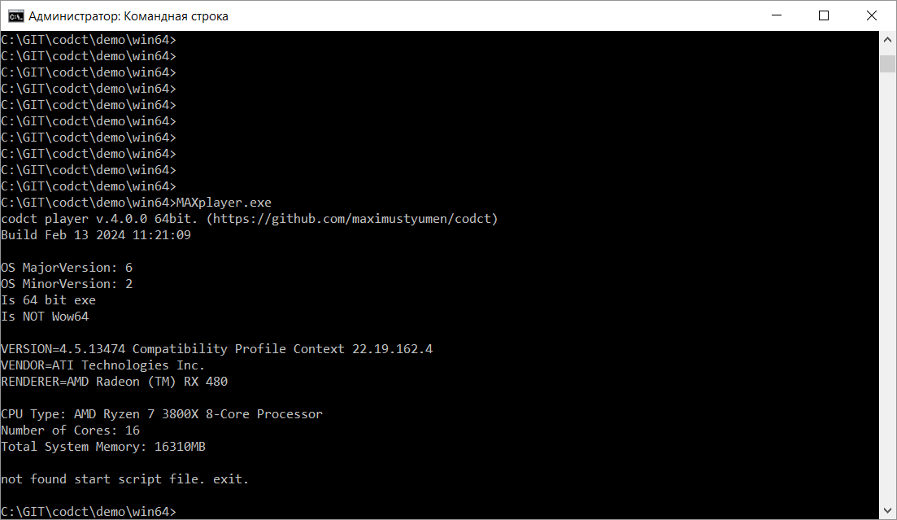

Результат запуска без параметров проекта

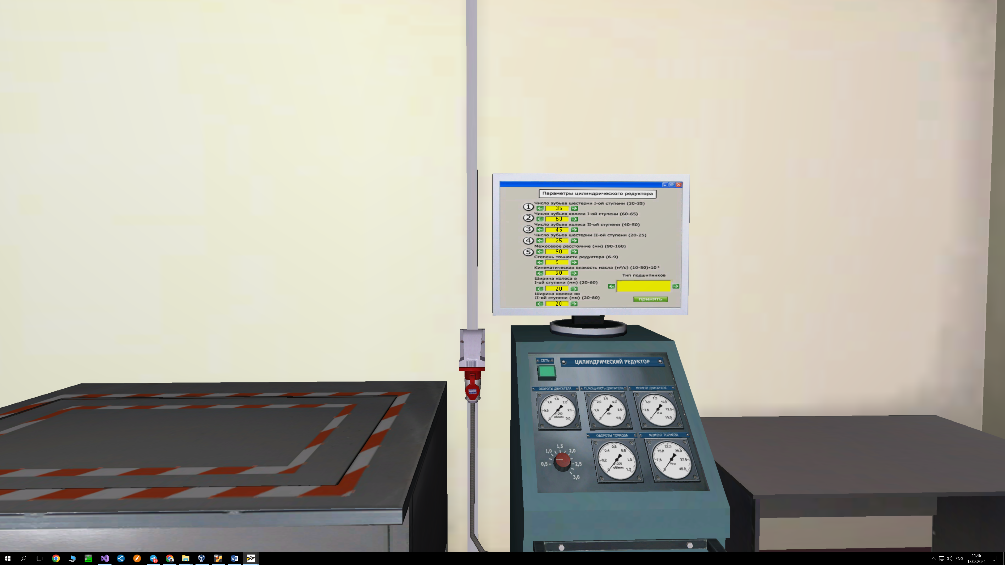

Результат запуска C:\GIT\codct\demo\win64_dm1\maxplayer.exe

uname -a   
Linux username-VB 5.15.0-94-generic #104~20.04.1-Ubuntu SMP Tue Jan 16 13:34:09 UTC 2024  
x86_64 x86_64 x86_64 GNU/Linux

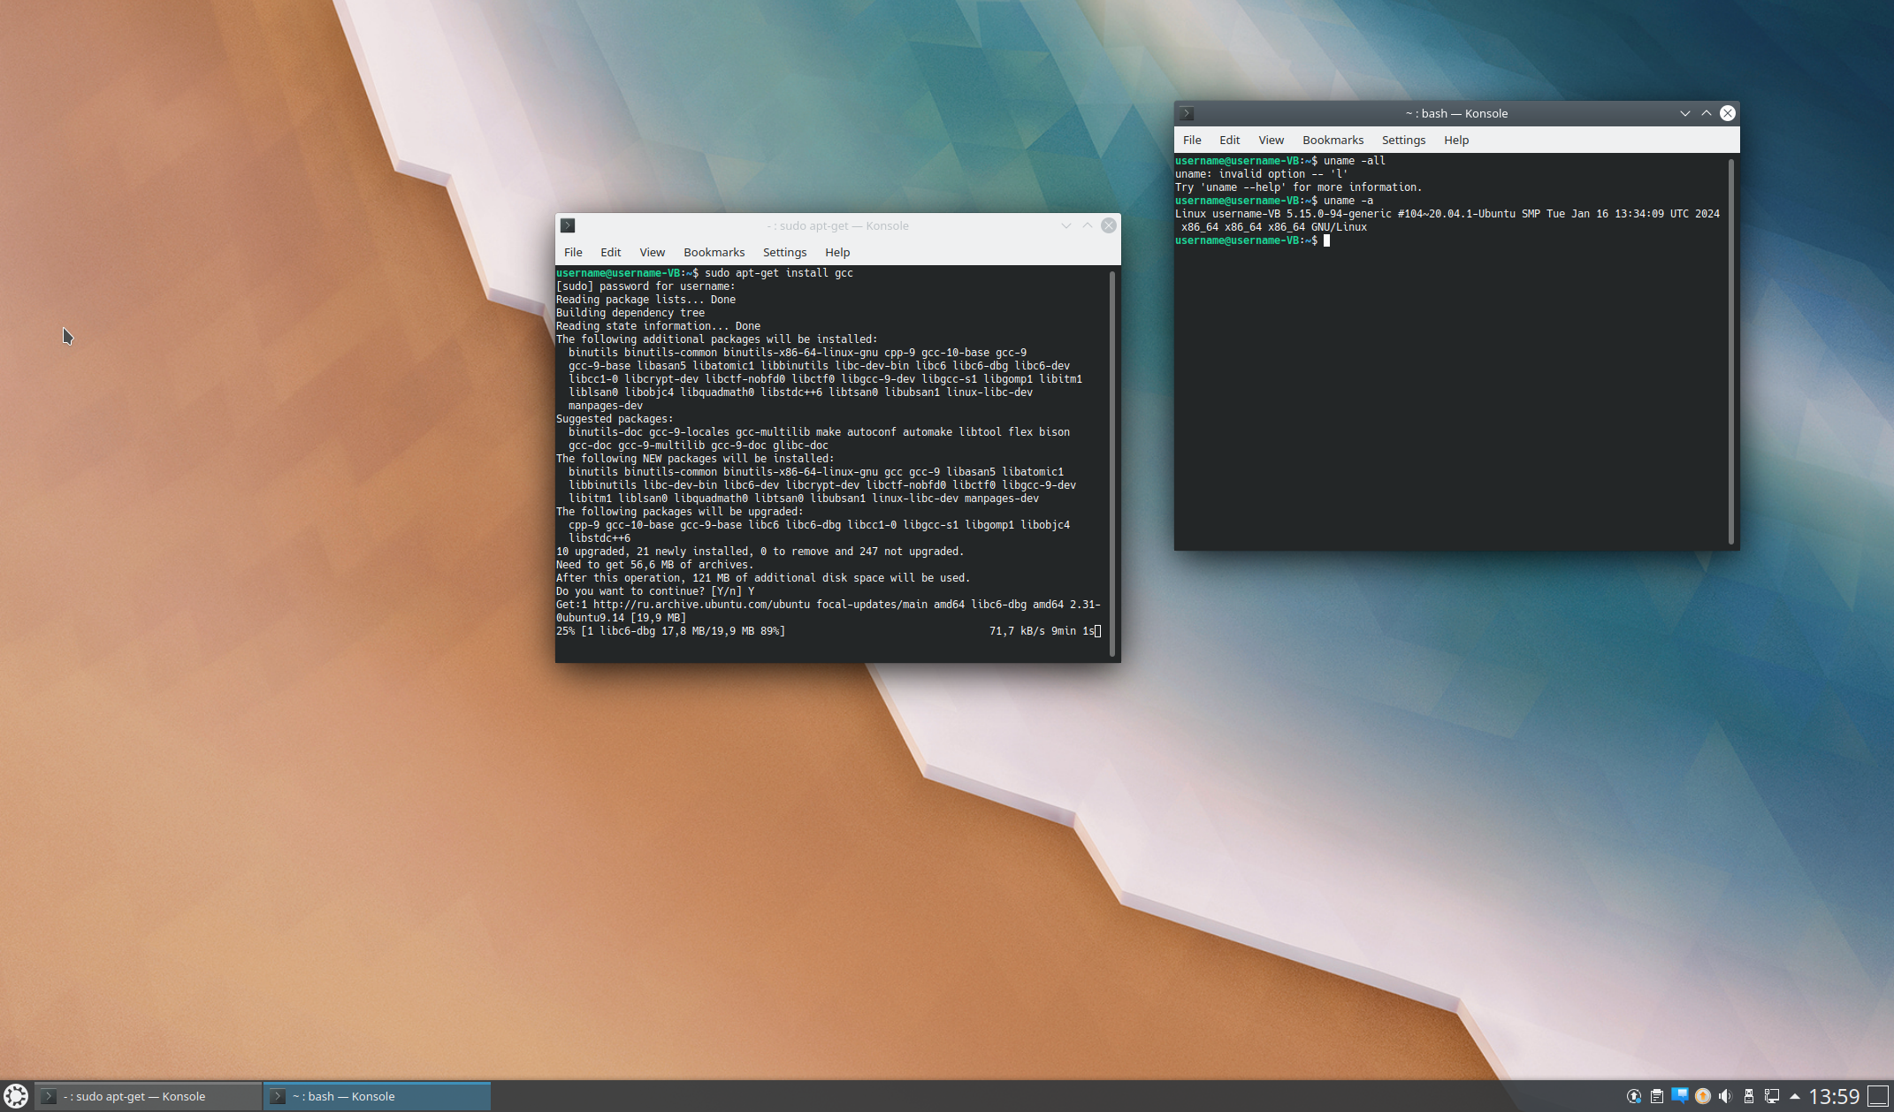

sudo apt-get install gcc

sudo apt-get -y install openscenegraph

sudo apt-get install libopenscenegraph-dev

sudo apt-get install git

sudo apt-get install make

sudo apt install lua5.3**sudo apt-get install libsdl2-2.0-0**

sudo apt install libsdl1.2-dev

sudo apt install g++sudo apt-get install curl

sudo apt-get -y install libcurl4-openssl-dev

sudo apt-get -y install libopenvr-dev

sudo apt install libopenal-dev

sudo apt install libalut-dev

sudo apt install liblua5.3-dev

sudo apt install libsdl2-dev

sudo apt-get install libvorbis-dev

sudo apt-get install freeglut3-dev

sudo apt install libsdl1.2-dev

mkdir codct

cd codct

~/codct$ git clone https://github.com/maximustyumen/codct .

cd constructor_player/cd src

make

username@username-VirtualBox:~$ cd codct/

username@username-VirtualBox:~/codct$ cd constructor_player/

username@username-VirtualBox:~/codct/constructor_player$ cd sr

bash: cd: sr: Нет такого файла или каталога

username@username-VirtualBox:~/codct/constructor_player$ cd src/

username@username-VirtualBox:~/codct/constructor_player/src$ make

g++ -c ./MAXplayer.cpp -std=c++11 -I/usr/include/SDL -I/usr/include/lua5.2 -I/home/maximum2000/DEVELOP/CERTI-3.4.1-Source/include

In file included from ././Scene/SceneClass.h:29,

from ./MAXplayer.h:34,

from ./MAXplayer.cpp:8:

././Scene/./Text/InterfaceForText.h:61:72: warning: dynamic exception specifications are deprecated in C++11 [-Wdeprecated]

61 | ::ref_ptr<BaseTextObject> FindTextObject(std::string name) throw (ErrorClass);

| ^~~~~

././Scene/./Text/InterfaceForText.h:64:65: warning: dynamic exception specifications are deprecated in C++11 [-Wdeprecated]

64 | bool _CreateText(std::string Name, std::string value) throw (ErrorClass);

| ^~~~~

In file included from ././Scene/SceneClass.h:31,

from ./MAXplayer.h:34,

from ./MAXplayer.cpp:8:

././Scene/./Shaders/InterfaceForShaders.h:50:14: warning: ‘template<class> class std::auto_ptr’ is deprecated: use 'std::unique_ptr' instead [-Wdeprecated-declarations]

50 | std::auto_ptr<BumpMaterial> m_bump_material;

| ^~~~~~~~

In file included from /usr/include/c++/11/bits/locale_conv.h:41,

from /usr/include/c++/11/locale:43,

from /usr/include/c++/11/iomanip:43,

from ./MAXplayer.h:2,

from ./MAXplayer.cpp:8:

/usr/include/c++/11/bits/unique_ptr.h:57:28: note: declared here

57 | template<typename> class auto_ptr;

| ^~~~~~~~

In file included from ././Scene/./Audio/AudioSceneClass.h:4,

from ././Scene/SceneClass.h:46,

from ./MAXplayer.h:34,

from ./MAXplayer.cpp:8:

././Scene/./Audio/BaseSoundObject.h:50:27: warning: dynamic exception specifications are deprecated in C++11 [-Wdeprecated]

50 | void TakeSource() throw (ErrorClass);;

| ^~~~~

././Scene/./Audio/BaseSoundObject.h:52:36: warning: dynamic exception specifications are deprecated in C++11 [-Wdeprecated]

52 | void RestoreSource(ALuint) throw (ErrorClass);;

| ^~~~~

In file included from ././Scene/./Audio/AudioSceneClass.h:4,

from ././Scene/SceneClass.h:46,

from ./MAXplayer.h:34,

from ./MAXplayer.cpp:8:

././Scene/./Audio/BaseSoundObject.h:67:75: warning: dynamic exception specifications are deprecated in C++11 [-Wdeprecated]

67 | pen(const std::string Filename, bool Looped, bool Streamed) throw (ErrorClass);

| ^~~~~

././Scene/./Audio/BaseSoundObject.h:69:21: warning: dynamic exception specifications are deprecated in C++11 [-Wdeprecated]

69 | void Play() throw (ErrorClass);

| ^~~~~

././Scene/./Audio/BaseSoundObject.h:71:35: warning: dynamic exception specifications are deprecated in C++11 [-Wdeprecated]

71 | void setLoop(bool Looped) throw (ErrorClass);

| ^~~~~

././Scene/./Audio/BaseSoundObject.h:73:22: warning: dynamic exception specifications are deprecated in C++11 [-Wdeprecated]

73 | void Pause() throw (ErrorClass);

| ^~~~~

././Scene/./Audio/BaseSoundObject.h:75:32: warning: dynamic exception specifications are deprecated in C++11 [-Wdeprecated]

75 | std::string GetState() throw (ErrorClass);

| ^~~~~

././Scene/./Audio/BaseSoundObject.h:77:29: warning: dynamic exception specifications are deprecated in C++11 [-Wdeprecated]

77 | void SetGain(float) throw (ErrorClass);

| ^~~~~

././Scene/./Audio/BaseSoundObject.h:79:36: warning: dynamic exception specifications are deprecated in C++11 [-Wdeprecated]

79 | void SetMaxDistance(float) throw (ErrorClass);

| ^~~~~

././Scene/./Audio/BaseSoundObject.h:81:42: warning: dynamic exception specifications are deprecated in C++11 [-Wdeprecated]

81 | void SetReferenceDistance(float) throw (ErrorClass);

| ^~~~~

././Scene/./Audio/BaseSoundObject.h:83:42: warning: dynamic exception specifications are deprecated in C++11 [-Wdeprecated]

83 | void SetMinMaxGain(float, float) throw (ErrorClass);

| ^~~~~

././Scene/./Audio/BaseSoundObject.h:85:31: warning: dynamic exception specifications are deprecated in C++11 [-Wdeprecated]

85 | void SetOFFSET(float) throw (ErrorClass);

| ^~~~~

././Scene/./Audio/BaseSoundObject.h:87:38: warning: dynamic exception specifications are deprecated in C++11 [-Wdeprecated]

87 | void SetRolloffFactor(float) throw (ErrorClass);

| ^~~~~

././Scene/./Audio/BaseSoundObject.h:182:55: warning: dynamic exception specifications are deprecated in C++11 [-Wdeprecated]

182 | bool LoadWavFile (const std::string Filename) throw (ErrorClass);

| ^~~~~

././Scene/./Audio/BaseSoundObject.h:203:71: warning: dynamic exception specifications are deprecated in C++11 [-Wdeprecated]

203 | ol LoadOggFile (const std::string &Filename, bool Streamed) throw (ErrorClass);

| ^~~~~

In file included from ././Scene/SceneClass.h:46,

from ./MAXplayer.h:34,

from ./MAXplayer.cpp:8:

././Scene/./Audio/AudioSceneClass.h:16:55: warning: dynamic exception specifications are deprecated in C++11 [-Wdeprecated]

16 | void NewObject(std::string Name, bool _value) throw (ErrorClass);

| ^~~~~

In file included from ././Scene/SceneClass.h:46,

from ./MAXplayer.h:34,

from ./MAXplayer.cpp:8:

././Scene/./Audio/AudioSceneClass.h:73:67: warning: dynamic exception specifications are deprecated in C++11 [-Wdeprecated]

73 | osg::ref_ptr<BaseSoundObject> FindSound(std::string name) throw (ErrorClass);

| ^~~~~

g++ -c ./user/User.cpp -std=c++11 -I/usr/include/SDL -I/usr/include/lua5.2 -I/home/maximum2000/DEVELOP/CERTI-3.4.1-Source/include

g++ -c ./user/UserHands.cpp -std=c++11 -I/usr/include/SDL -I/usr/include/lua5.2 -I/home/maximum2000/DEVELOP/CERTI-3.4.1-Source/include

g++ -c ./user/UserFoot.cpp -std=c++11 -I/usr/include/SDL -I/usr/include/lua5.2 -I/home/maximum2000/DEVELOP/CERTI-3.4.1-Source/include

g++ -c ./user/JoyDataClass.cpp -std=c++11 -I/usr/include/SDL -I/usr/include/lua5.2 -I/home/maximum2000/DEVELOP/CERTI-3.4.1-Source/include

g++ -c ./user/HeadDataClass.cpp -std=c++11 -I/usr/include/SDL -I/usr/include/lua5.2 -I/home/maximum2000/DEVELOP/CERTI-3.4.1-Source/include

g++ -c ./user/HandsDataClass.cpp -std=c++11 -I/usr/include/SDL -I/usr/include/lua5.2 -I/home/maximum2000/DEVELOP/CERTI-3.4.1-Source/include

g++ -c ./user/FootDataClass.cpp -std=c++11 -I/usr/include/SDL -I/usr/include/lua5.2 -I/home/maximum2000/DEVELOP/CERTI-3.4.1-Source/include

g++ -c ./user/events/InternalEventClass.cpp -std=c++11 -I/usr/include/SDL -I/usr/include/lua5.2 -I/home/maximum2000/DEVELOP/CERTI-3.4.1-Source/include

g++ -c ./user/input/Input.cpp -std=c++11 -I/usr/include/SDL -I/usr/include/lua5.2 -I/home/maximum2000/DEVELOP/CERTI-3.4.1-Source/include

g++ -c ./user/input/InputKeyboard.cpp -std=c++11 -I/usr/include/SDL -I/usr/include/lua5.2 -I/home/maximum2000/DEVELOP/CERTI-3.4.1-Source/include

g++ -c ./user/input/InputKeys.cpp -std=c++11 -I/usr/include/SDL -I/usr/include/lua5.2 -I/home/maximum2000/DEVELOP/CERTI-3.4.1-Source/include

g++ -c ./user/input/keytranslation.cpp -std=c++11 -I/usr/include/SDL -I/usr/include/lua5.2 -I/home/maximum2000/DEVELOP/CERTI-3.4.1-Source/include

g++ -c ./user/input/InputMouse.cpp -std=c++11 -I/usr/include/SDL -I/usr/include/lua5.2 -I/home/maximum2000/DEVELOP/CERTI-3.4.1-Source/include

g++ -c ./user/input/Joystick/InputJoystick.cpp -std=c++11 -I/usr/include/SDL -I/usr/include/lua5.2 -I/home/maximum2000/DEVELOP/CERTI-3.4.1-Source/include

g++ -c ./user/output/Output.cpp -std=c++11 -I/usr/include/SDL -I/usr/include/lua5.2 -I/home/maximum2000/DEVELOP/CERTI-3.4.1-Source/include

g++ -c ./user/output/OutputAudio.cpp -std=c++11 -I/usr/include/SDL -I/usr/include/lua5.2 -I/home/maximum2000/DEVELOP/CERTI-3.4.1-Source/include

./user/output/OutputAudio.cpp: In member function ‘ALboolean OutputAudioClass::CheckALCError()’:

./user/output/OutputAudio.cpp:152:15: warning: format not a string literal and no format arguments [-Wformat-security]

152 | printf(Err.data());

| ~~~~~~^~~~~~~~~~~~

g++ -c ./user/output/OutputVideo.cpp -std=c++11 -I/usr/include/SDL -I/usr/include/lua5.2 -I/home/maximum2000/DEVELOP/CERTI-3.4.1-Source/include

g++ -c ./Scene/SceneClass.cpp -std=c++11 -I/usr/include/SDL -I/usr/include/lua5.2 -I/home/maximum2000/DEVELOP/CERTI-3.4.1-Source/include

In file included from ./Scene/SceneClass.h:29,

from ./Scene/SceneClass.cpp:8:

./Scene/./Text/InterfaceForText.h:61:72: warning: dynamic exception specifications are deprecated in C++11 [-Wdeprecated]

61 | ::ref_ptr<BaseTextObject> FindTextObject(std::string name) throw (ErrorClass);

| ^~~~~

./Scene/./Text/InterfaceForText.h:64:65: warning: dynamic exception specifications are deprecated in C++11 [-Wdeprecated]

64 | bool _CreateText(std::string Name, std::string value) throw (ErrorClass);

| ^~~~~

In file included from ./Scene/SceneClass.h:31,

from ./Scene/SceneClass.cpp:8:

./Scene/./Shaders/InterfaceForShaders.h:50:14: warning: ‘template<class> class std::auto_ptr’ is deprecated: use 'std::unique_ptr' instead [-Wdeprecated-declarations]

50 | std::auto_ptr<BumpMaterial> m_bump_material;

| ^~~~~~~~

In file included from /usr/include/c++/11/memory:76,

from ./Scene/./Shaders/InterfaceForShaders.h:4,

from ./Scene/SceneClass.h:31,

from ./Scene/SceneClass.cpp:8:

/usr/include/c++/11/bits/unique_ptr.h:57:28: note: declared here

57 | template<typename> class auto_ptr;

| ^~~~~~~~

In file included from ./Scene/./Audio/AudioSceneClass.h:4,

from ./Scene/SceneClass.h:46,

from ./Scene/SceneClass.cpp:8:

./Scene/./Audio/BaseSoundObject.h:50:27: warning: dynamic exception specifications are deprecated in C++11 [-Wdeprecated]

50 | void TakeSource() throw (ErrorClass);;

| ^~~~~

./Scene/./Audio/BaseSoundObject.h:52:36: warning: dynamic exception specifications are deprecated in C++11 [-Wdeprecated]

52 | void RestoreSource(ALuint) throw (ErrorClass);;

| ^~~~~

In file included from ./Scene/./Audio/AudioSceneClass.h:4,

from ./Scene/SceneClass.h:46,

from ./Scene/SceneClass.cpp:8:

./Scene/./Audio/BaseSoundObject.h:67:75: warning: dynamic exception specifications are deprecated in C++11 [-Wdeprecated]

67 | pen(const std::string Filename, bool Looped, bool Streamed) throw (ErrorClass);

| ^~~~~

./Scene/./Audio/BaseSoundObject.h:69:21: warning: dynamic exception specifications are deprecated in C++11 [-Wdeprecated]

69 | void Play() throw (ErrorClass);

| ^~~~~

./Scene/./Audio/BaseSoundObject.h:71:35: warning: dynamic exception specifications are deprecated in C++11 [-Wdeprecated]

71 | void setLoop(bool Looped) throw (ErrorClass);

| ^~~~~

./Scene/./Audio/BaseSoundObject.h:73:22: warning: dynamic exception specifications are deprecated in C++11 [-Wdeprecated]

73 | void Pause() throw (ErrorClass);

| ^~~~~

./Scene/./Audio/BaseSoundObject.h:75:32: warning: dynamic exception specifications are deprecated in C++11 [-Wdeprecated]

75 | std::string GetState() throw (ErrorClass);

| ^~~~~

./Scene/./Audio/BaseSoundObject.h:77:29: warning: dynamic exception specifications are deprecated in C++11 [-Wdeprecated]

77 | void SetGain(float) throw (ErrorClass);

| ^~~~~

./Scene/./Audio/BaseSoundObject.h:79:36: warning: dynamic exception specifications are deprecated in C++11 [-Wdeprecated]

79 | void SetMaxDistance(float) throw (ErrorClass);

| ^~~~~

./Scene/./Audio/BaseSoundObject.h:81:42: warning: dynamic exception specifications are deprecated in C++11 [-Wdeprecated]

81 | void SetReferenceDistance(float) throw (ErrorClass);

| ^~~~~

./Scene/./Audio/BaseSoundObject.h:83:42: warning: dynamic exception specifications are deprecated in C++11 [-Wdeprecated]

83 | void SetMinMaxGain(float, float) throw (ErrorClass);

| ^~~~~

./Scene/./Audio/BaseSoundObject.h:85:31: warning: dynamic exception specifications are deprecated in C++11 [-Wdeprecated]

85 | void SetOFFSET(float) throw (ErrorClass);

| ^~~~~

./Scene/./Audio/BaseSoundObject.h:87:38: warning: dynamic exception specifications are deprecated in C++11 [-Wdeprecated]

87 | void SetRolloffFactor(float) throw (ErrorClass);

| ^~~~~

./Scene/./Audio/BaseSoundObject.h:182:55: warning: dynamic exception specifications are deprecated in C++11 [-Wdeprecated]

182 | bool LoadWavFile (const std::string Filename) throw (ErrorClass);

| ^~~~~

./Scene/./Audio/BaseSoundObject.h:203:71: warning: dynamic exception specifications are deprecated in C++11 [-Wdeprecated]

203 | ol LoadOggFile (const std::string &Filename, bool Streamed) throw (ErrorClass);

| ^~~~~

In file included from ./Scene/SceneClass.h:46,

from ./Scene/SceneClass.cpp:8:

./Scene/./Audio/AudioSceneClass.h:16:55: warning: dynamic exception specifications are deprecated in C++11 [-Wdeprecated]

16 | void NewObject(std::string Name, bool _value) throw (ErrorClass);

| ^~~~~

In file included from ./Scene/SceneClass.h:46,

from ./Scene/SceneClass.cpp:8:

./Scene/./Audio/AudioSceneClass.h:73:67: warning: dynamic exception specifications are deprecated in C++11 [-Wdeprecated]

73 | osg::ref_ptr<BaseSoundObject> FindSound(std::string name) throw (ErrorClass);

| ^~~~~

g++ -c ./Scene/Audio/AudioSceneClass.cpp -std=c++11 -I/usr/include/SDL -I/usr/include/lua5.2 -I/home/maximum2000/DEVELOP/CERTI-3.4.1-Source/include

In file included from ./Scene/Audio/AudioSceneClass.h:4,

from ./Scene/Audio/AudioSceneClass.cpp:9:

./Scene/Audio/BaseSoundObject.h:50:27: warning: dynamic exception specifications are deprecated in C++11 [-Wdeprecated]

50 | void TakeSource() throw (ErrorClass);;

| ^~~~~

./Scene/Audio/BaseSoundObject.h:52:36: warning: dynamic exception specifications are deprecated in C++11 [-Wdeprecated]

52 | void RestoreSource(ALuint) throw (ErrorClass);;

| ^~~~~

In file included from ./Scene/Audio/AudioSceneClass.h:4,

from ./Scene/Audio/AudioSceneClass.cpp:9:

./Scene/Audio/BaseSoundObject.h:67:75: warning: dynamic exception specifications are deprecated in C++11 [-Wdeprecated]

67 | pen(const std::string Filename, bool Looped, bool Streamed) throw (ErrorClass);

| ^~~~~

./Scene/Audio/BaseSoundObject.h:69:21: warning: dynamic exception specifications are deprecated in C++11 [-Wdeprecated]

69 | void Play() throw (ErrorClass);

| ^~~~~

./Scene/Audio/BaseSoundObject.h:71:35: warning: dynamic exception specifications are deprecated in C++11 [-Wdeprecated]

71 | void setLoop(bool Looped) throw (ErrorClass);

| ^~~~~

./Scene/Audio/BaseSoundObject.h:73:22: warning: dynamic exception specifications are deprecated in C++11 [-Wdeprecated]

73 | void Pause() throw (ErrorClass);

| ^~~~~

./Scene/Audio/BaseSoundObject.h:75:32: warning: dynamic exception specifications are deprecated in C++11 [-Wdeprecated]

75 | std::string GetState() throw (ErrorClass);

| ^~~~~

./Scene/Audio/BaseSoundObject.h:77:29: warning: dynamic exception specifications are deprecated in C++11 [-Wdeprecated]

77 | void SetGain(float) throw (ErrorClass);

| ^~~~~

./Scene/Audio/BaseSoundObject.h:79:36: warning: dynamic exception specifications are deprecated in C++11 [-Wdeprecated]

79 | void SetMaxDistance(float) throw (ErrorClass);

| ^~~~~

./Scene/Audio/BaseSoundObject.h:81:42: warning: dynamic exception specifications are deprecated in C++11 [-Wdeprecated]

81 | void SetReferenceDistance(float) throw (ErrorClass);

| ^~~~~

./Scene/Audio/BaseSoundObject.h:83:42: warning: dynamic exception specifications are deprecated in C++11 [-Wdeprecated]

83 | void SetMinMaxGain(float, float) throw (ErrorClass);

| ^~~~~

./Scene/Audio/BaseSoundObject.h:85:31: warning: dynamic exception specifications are deprecated in C++11 [-Wdeprecated]

85 | void SetOFFSET(float) throw (ErrorClass);

| ^~~~~

./Scene/Audio/BaseSoundObject.h:87:38: warning: dynamic exception specifications are deprecated in C++11 [-Wdeprecated]

87 | void SetRolloffFactor(float) throw (ErrorClass);

| ^~~~~

./Scene/Audio/BaseSoundObject.h:182:55: warning: dynamic exception specifications are deprecated in C++11 [-Wdeprecated]

182 | bool LoadWavFile (const std::string Filename) throw (ErrorClass);

| ^~~~~

./Scene/Audio/BaseSoundObject.h:203:71: warning: dynamic exception specifications are deprecated in C++11 [-Wdeprecated]

203 | ol LoadOggFile (const std::string &Filename, bool Streamed) throw (ErrorClass);

| ^~~~~

In file included from ./Scene/Audio/AudioSceneClass.cpp:9:

./Scene/Audio/AudioSceneClass.h:16:55: warning: dynamic exception specifications are deprecated in C++11 [-Wdeprecated]

16 | void NewObject(std::string Name, bool _value) throw (ErrorClass);

| ^~~~~

In file included from ./Scene/Audio/AudioSceneClass.cpp:9:

./Scene/Audio/AudioSceneClass.h:73:67: warning: dynamic exception specifications are deprecated in C++11 [-Wdeprecated]

73 | osg::ref_ptr<BaseSoundObject> FindSound(std::string name) throw (ErrorClass);

| ^~~~~

./Scene/Audio/AudioSceneClass.cpp:178:64: warning: dynamic exception specifications are deprecated in C++11 [-Wdeprecated]

178 | d AudioSceneClass::NewObject(std::string Name, bool _value) throw (ErrorClass)

| ^~~~~

./Scene/Audio/AudioSceneClass.cpp:214:77: warning: dynamic exception specifications are deprecated in C++11 [-Wdeprecated]

214 | eSoundObject> AudioSceneClass::FindSound(std::string name) throw (ErrorClass)

| ^~~~~

g++ -c ./Scene/Audio/BaseSoundObject.cpp -std=c++11 -I/usr/include/SDL -I/usr/include/lua5.2 -I/home/maximum2000/DEVELOP/CERTI-3.4.1-Source/include

In file included from ./Scene/Audio/BaseSoundObject.cpp:9:

./Scene/Audio/BaseSoundObject.h:50:27: warning: dynamic exception specifications are deprecated in C++11 [-Wdeprecated]

50 | void TakeSource() throw (ErrorClass);;

| ^~~~~

./Scene/Audio/BaseSoundObject.h:52:36: warning: dynamic exception specifications are deprecated in C++11 [-Wdeprecated]

52 | void RestoreSource(ALuint) throw (ErrorClass);;

| ^~~~~

In file included from ./Scene/Audio/BaseSoundObject.cpp:9:

./Scene/Audio/BaseSoundObject.h:67:75: warning: dynamic exception specifications are deprecated in C++11 [-Wdeprecated]

67 | pen(const std::string Filename, bool Looped, bool Streamed) throw (ErrorClass);

| ^~~~~

./Scene/Audio/BaseSoundObject.h:69:21: warning: dynamic exception specifications are deprecated in C++11 [-Wdeprecated]

69 | void Play() throw (ErrorClass);

| ^~~~~

./Scene/Audio/BaseSoundObject.h:71:35: warning: dynamic exception specifications are deprecated in C++11 [-Wdeprecated]

71 | void setLoop(bool Looped) throw (ErrorClass);

| ^~~~~

./Scene/Audio/BaseSoundObject.h:73:22: warning: dynamic exception specifications are deprecated in C++11 [-Wdeprecated]

73 | void Pause() throw (ErrorClass);

| ^~~~~

./Scene/Audio/BaseSoundObject.h:75:32: warning: dynamic exception specifications are deprecated in C++11 [-Wdeprecated]

75 | std::string GetState() throw (ErrorClass);

| ^~~~~

./Scene/Audio/BaseSoundObject.h:77:29: warning: dynamic exception specifications are deprecated in C++11 [-Wdeprecated]

77 | void SetGain(float) throw (ErrorClass);

| ^~~~~

./Scene/Audio/BaseSoundObject.h:79:36: warning: dynamic exception specifications are deprecated in C++11 [-Wdeprecated]

79 | void SetMaxDistance(float) throw (ErrorClass);

| ^~~~~

./Scene/Audio/BaseSoundObject.h:81:42: warning: dynamic exception specifications are deprecated in C++11 [-Wdeprecated]

81 | void SetReferenceDistance(float) throw (ErrorClass);

| ^~~~~

./Scene/Audio/BaseSoundObject.h:83:42: warning: dynamic exception specifications are deprecated in C++11 [-Wdeprecated]

83 | void SetMinMaxGain(float, float) throw (ErrorClass);

| ^~~~~

./Scene/Audio/BaseSoundObject.h:85:31: warning: dynamic exception specifications are deprecated in C++11 [-Wdeprecated]

85 | void SetOFFSET(float) throw (ErrorClass);

| ^~~~~

./Scene/Audio/BaseSoundObject.h:87:38: warning: dynamic exception specifications are deprecated in C++11 [-Wdeprecated]

87 | void SetRolloffFactor(float) throw (ErrorClass);

| ^~~~~

./Scene/Audio/BaseSoundObject.h:182:55: warning: dynamic exception specifications are deprecated in C++11 [-Wdeprecated]

182 | bool LoadWavFile (const std::string Filename) throw (ErrorClass);

| ^~~~~

./Scene/Audio/BaseSoundObject.h:203:71: warning: dynamic exception specifications are deprecated in C++11 [-Wdeprecated]

203 | ol LoadOggFile (const std::string &Filename, bool Streamed) throw (ErrorClass);

| ^~~~~

./Scene/Audio/BaseSoundObject.cpp: In destructor ‘virtual BaseSoundObject::~BaseSoundObject()’:

./Scene/Audio/BaseSoundObject.cpp:97:41: warning: passing NULL to non-pointer argument 3 of ‘void alSourcei(ALuint, ALenum, ALint)’ [-Wconversion-null]

97 | alSourcei(mSourceID, AL_BUFFER, NULL); //+

| ^~~~

In file included from ./Scene/Audio/BaseSoundObject.h:17,

from ./Scene/Audio/BaseSoundObject.cpp:9:

/usr/include/AL/al.h:514:70: note: declared here

514 | I void AL_APIENTRY alSourcei(ALuint source, ALenum param, ALint value);

| ~~~~~~^~~~~

./Scene/Audio/BaseSoundObject.cpp: At global scope:

./Scene/Audio/BaseSoundObject.cpp:132:36: warning: dynamic exception specifications are deprecated in C++11 [-Wdeprecated]

132 | void BaseSoundObject::TakeSource() throw (ErrorClass)

| ^~~~~

./Scene/Audio/BaseSoundObject.cpp: In member function ‘void BaseSoundObject::TakeSource()’:

./Scene/Audio/BaseSoundObject.cpp:141:49: warning: passing NULL to non-pointer argument 3 of ‘void alSourcei(ALuint, ALenum, ALint)’ [-Wconversion-null]

141 | alSourcei(mSourceID, AL_BUFFER, NULL); //+

| ^~~~

In file included from ./Scene/Audio/BaseSoundObject.h:17,

from ./Scene/Audio/BaseSoundObject.cpp:9:

/usr/include/AL/al.h:514:70: note: declared here

514 | I void AL_APIENTRY alSourcei(ALuint source, ALenum param, ALint value);

| ~~~~~~^~~~~

./Scene/Audio/BaseSoundObject.cpp: At global scope:

./Scene/Audio/BaseSoundObject.cpp:158:57: warning: dynamic exception specifications are deprecated in C++11 [-Wdeprecated]

158 | void BaseSoundObject::RestoreSource(ALuint newSourceID) throw (ErrorClass)

| ^~~~~

./Scene/Audio/BaseSoundObject.cpp:308:84: warning: dynamic exception specifications are deprecated in C++11 [-Wdeprecated]

308 | pen(const std::string Filename, bool Looped, bool Streamed) throw (ErrorClass)

| ^~~~~

./Scene/Audio/BaseSoundObject.cpp:338:30: warning: dynamic exception specifications are deprecated in C++11 [-Wdeprecated]

338 | void BaseSoundObject::Play() throw (ErrorClass)

| ^~~~~

./Scene/Audio/BaseSoundObject.cpp:359:44: warning: dynamic exception specifications are deprecated in C++11 [-Wdeprecated]

359 | void BaseSoundObject::setLoop(bool Looped) throw (ErrorClass)

| ^~~~~

./Scene/Audio/BaseSoundObject.cpp:375:31: warning: dynamic exception specifications are deprecated in C++11 [-Wdeprecated]

375 | void BaseSoundObject::Pause() throw (ErrorClass)

| ^~~~~

./Scene/Audio/BaseSoundObject.cpp:391:41: warning: dynamic exception specifications are deprecated in C++11 [-Wdeprecated]

391 | std::string BaseSoundObject::GetState() throw (ErrorClass)

| ^~~~~

./Scene/Audio/BaseSoundObject.cpp:425:44: warning: dynamic exception specifications are deprecated in C++11 [-Wdeprecated]

425 | void BaseSoundObject::SetGain(float value) throw (ErrorClass)

| ^~~~~

./Scene/Audio/BaseSoundObject.cpp:440:51: warning: dynamic exception specifications are deprecated in C++11 [-Wdeprecated]

440 | void BaseSoundObject::SetMaxDistance(float value) throw (ErrorClass)

| ^~~~~

./Scene/Audio/BaseSoundObject.cpp:455:57: warning: dynamic exception specifications are deprecated in C++11 [-Wdeprecated]

455 | void BaseSoundObject::SetReferenceDistance(float value) throw (ErrorClass)

| ^~~~~

./Scene/Audio/BaseSoundObject.cpp:470:59: warning: dynamic exception specifications are deprecated in C++11 [-Wdeprecated]

470 | void BaseSoundObject::SetMinMaxGain(float min, float max) throw (ErrorClass)

| ^~~~~

./Scene/Audio/BaseSoundObject.cpp:487:47: warning: dynamic exception specifications are deprecated in C++11 [-Wdeprecated]

487 | void BaseSoundObject::SetOFFSET(float offset) throw (ErrorClass)

| ^~~~~

./Scene/Audio/BaseSoundObject.cpp:502:53: warning: dynamic exception specifications are deprecated in C++11 [-Wdeprecated]

502 | void BaseSoundObject::SetRolloffFactor(float value) throw (ErrorClass)

| ^~~~~

./Scene/Audio/BaseSoundObject.cpp:591:63: warning: dynamic exception specifications are deprecated in C++11 [-Wdeprecated]

591 | ol BaseSoundObject::LoadWavFile(const std::string filename) throw (ErrorClass)

| ^~~~~

./Scene/Audio/BaseSoundObject.cpp:624:79: warning: dynamic exception specifications are deprecated in C++11 [-Wdeprecated]

624 | ct::LoadOggFile(const std::string &Filename, bool Streamed) throw (ErrorClass)

| ^~~~~

g++ -c ./Scene/Graphic/GraphicSceneClass.cpp -std=c++11 -I/usr/include/SDL -I/usr/include/lua5.2 -I/home/maximum2000/DEVELOP/CERTI-3.4.1-Source/include

g++ -c ./Scene/HUD/InterfaceForHUD.cpp -std=c++11 -I/usr/include/SDL -I/usr/include/lua5.2 -I/home/maximum2000/DEVELOP/CERTI-3.4.1-Source/include

g++ -c ./Scene/Light/lightManager.cpp -std=c++11 -I/usr/include/SDL -I/usr/include/lua5.2 -I/home/maximum2000/DEVELOP/CERTI-3.4.1-Source/include

g++ -c ./Scene/Light/InterfaceForLight.cpp -std=c++11 -I/usr/include/SDL -I/usr/include/lua5.2 -I/home/maximum2000/DEVELOP/CERTI-3.4.1-Source/include

g++ -c ./Scene/OLD/Base3DObject.cpp -std=c++11 -I/usr/include/SDL -I/usr/include/lua5.2 -I/home/maximum2000/DEVELOP/CERTI-3.4.1-Source/include

g++ -c ./Scene/OLD/InterfaceForOLD.cpp -std=c++11 -I/usr/include/SDL -I/usr/include/lua5.2 -I/home/maximum2000/DEVELOP/CERTI-3.4.1-Source/include

g++ -c ./Scene/Particle/InterfaceForParticle.cpp -std=c++11 -I/usr/include/SDL -I/usr/include/lua5.2 -I/home/maximum2000/DEVELOP/CERTI-3.4.1-Source/include

./Scene/Particle/InterfaceForParticle.cpp: In member function ‘bool InterfaceForParticle::AddParticle(std::string)’:

./Scene/Particle/InterfaceForParticle.cpp:55:1: warning: control reaches end of non-void function [-Wreturn-type]

55 | }

| ^

./Scene/Particle/InterfaceForParticle.cpp: In member function ‘osg::ref_ptr<BaseParticleObject> InterfaceForParticle::FindParticleObject(std::string)’:

./Scene/Particle/InterfaceForParticle.cpp:167:1: warning: control reaches end of non-void function [-Wreturn-type]

167 | }

| ^

g++ -c ./Scene/Particle/BaseParticleObject.cpp -std=c++11 -I/usr/include/SDL -I/usr/include/lua5.2 -I/home/maximum2000/DEVELOP/CERTI-3.4.1-Source/include

g++ -c ./Scene/Shaders/InterfaceForShaders.cpp -std=c++11 -I/usr/include/SDL -I/usr/include/lua5.2 -I/home/maximum2000/DEVELOP/CERTI-3.4.1-Source/include

In file included from ./Scene/Shaders/InterfaceForShaders.cpp:8:

./Scene/Shaders/./InterfaceForShaders.h:50:14: warning: ‘template<class> class std::auto_ptr’ is deprecated: use 'std::unique_ptr' instead [-Wdeprecated-declarations]

50 | std::auto_ptr<BumpMaterial> m_bump_material;

| ^~~~~~~~

In file included from /usr/include/c++/11/memory:76,

from ./Scene/Shaders/./InterfaceForShaders.h:4,

from ./Scene/Shaders/InterfaceForShaders.cpp:8:

/usr/include/c++/11/bits/unique_ptr.h:57:28: note: declared here

57 | template<typename> class auto_ptr;

| ^~~~~~~~

In file included from ./Scene/Shaders/InterfaceForShaders.cpp:9:

./Scene/Shaders/BumpMaterial.h:59:14: warning: ‘template<class> class std::auto_ptr’ is deprecated: use 'std::unique_ptr' instead [-Wdeprecated-declarations]

59 | std::auto_ptr<BumpProgram> m_relief;

| ^~~~~~~~

In file included from /usr/include/c++/11/memory:76,

from ./Scene/Shaders/./InterfaceForShaders.h:4,

from ./Scene/Shaders/InterfaceForShaders.cpp:8:

/usr/include/c++/11/bits/unique_ptr.h:57:28: note: declared here

57 | template<typename> class auto_ptr;

| ^~~~~~~~

g++ -c ./Scene/Text/InterfaceForText.cpp -std=c++11 -I/usr/include/SDL -I/usr/include/lua5.2 -I/home/maximum2000/DEVELOP/CERTI-3.4.1-Source/include

In file included from ./Scene/Text/InterfaceForText.cpp:10:

./Scene/Text/./InterfaceForText.h:61:72: warning: dynamic exception specifications are deprecated in C++11 [-Wdeprecated]

61 | ::ref_ptr<BaseTextObject> FindTextObject(std::string name) throw (ErrorClass);

| ^~~~~

./Scene/Text/./InterfaceForText.h:64:65: warning: dynamic exception specifications are deprecated in C++11 [-Wdeprecated]

64 | bool _CreateText(std::string Name, std::string value) throw (ErrorClass);

| ^~~~~

./Scene/Text/InterfaceForText.cpp:46:74: warning: dynamic exception specifications are deprecated in C++11 [-Wdeprecated]

46 | ceForText::_CreateText(std::string Name, std::string value) throw (ErrorClass)

| ^~~~~

./Scene/Text/InterfaceForText.cpp:180:81: warning: dynamic exception specifications are deprecated in C++11 [-Wdeprecated]

180 | tObject> InterfaceForText::FindTextObject(std::string name) throw (ErrorClass)

| ^~~~~

g++ -c ./Scene/Text/BaseTextObject.cpp -std=c++11 -I/usr/include/SDL -I/usr/include/lua5.2 -I/home/maximum2000/DEVELOP/CERTI-3.4.1-Source/include

g++ -c ./Scene/Video/InterfaceForVideo.cpp -std=c++11 -I/usr/include/SDL -I/usr/include/lua5.2 -I/home/maximum2000/DEVELOP/CERTI-3.4.1-Source/include

./Scene/Video/InterfaceForVideo.cpp: In member function ‘bool InterfaceForVideo::CreateVideoPlane(std::string, std::string)’:

./Scene/Video/InterfaceForVideo.cpp:92:1: warning: control reaches end of non-void function [-Wreturn-type]

92 | }

| ^

./Scene/Video/InterfaceForVideo.cpp: In member function ‘osg::ref_ptr<BaseVideoObject> InterfaceForVideo::FindVideoObject(std::string)’:

./Scene/Video/InterfaceForVideo.cpp:172:1: warning: control reaches end of non-void function [-Wreturn-type]

172 | }

| ^

g++ -c ./Scene/Video/BaseVideoObject.cpp -std=c++11 -I/usr/include/SDL -I/usr/include/lua5.2 -I/home/maximum2000/DEVELOP/CERTI-3.4.1-Source/include

g++ -c ./Scene/Visitors/FindAnimationByName.cpp -std=c++11 -I/usr/include/SDL -I/usr/include/lua5.2 -I/home/maximum2000/DEVELOP/CERTI-3.4.1-Source/include

g++ -c ./Scene/Visitors/FindGeometry.cpp -std=c++11 -I/usr/include/SDL -I/usr/include/lua5.2 -I/home/maximum2000/DEVELOP/CERTI-3.4.1-Source/include

g++ -c ./Scene/Visitors/FindImageStreamsVisitor.cpp -std=c++11 -I/usr/include/SDL -I/usr/include/lua5.2 -I/home/maximum2000/DEVELOP/CERTI-3.4.1-Source/include

g++ -c ./Scene/Visitors/FindLightByName.cpp -std=c++11 -I/usr/include/SDL -I/usr/include/lua5.2 -I/home/maximum2000/DEVELOP/CERTI-3.4.1-Source/include

g++ -c ./Scene/Visitors/FindNodeByName.cpp -std=c++11 -I/usr/include/SDL -I/usr/include/lua5.2 -I/home/maximum2000/DEVELOP/CERTI-3.4.1-Source/include

g++ -c ./Scene/Visitors/FindTexture.cpp -std=c++11 -I/usr/include/SDL -I/usr/include/lua5.2 -I/home/maximum2000/DEVELOP/CERTI-3.4.1-Source/include

g++ -c ./Scene/Visitors/RenameAllNode.cpp -std=c++11 -I/usr/include/SDL -I/usr/include/lua5.2 -I/home/maximum2000/DEVELOP/CERTI-3.4.1-Source/include

g++ -c ./Configure/Configure.cpp -std=c++11 -I/usr/include/SDL -I/usr/include/lua5.2 -I/home/maximum2000/DEVELOP/CERTI-3.4.1-Source/include

g++ -c ./SCORM/interfaceforscorm.cpp -std=c++11 -I/usr/include/SDL -I/usr/include/lua5.2 -I/home/maximum2000/DEVELOP/CERTI-3.4.1-Source/include

g++ -c ./TinCan/InterfaceForTinCan.cpp -std=c++11 -I/usr/include/SDL -I/usr/include/lua5.2 -I/home/maximum2000/DEVELOP/CERTI-3.4.1-Source/include

g++ -c ./TinCan/cJSON.c -std=c++11 -I/usr/include/SDL -I/usr/include/lua5.2 -I/home/maximum2000/DEVELOP/CERTI-3.4.1-Source/include

g++ -c ./Configure/Console.cpp -std=c++11 -I/usr/include/SDL -I/usr/include/lua5.2 -I/home/maximum2000/DEVELOP/CERTI-3.4.1-Source/include

g++ -c ./RTI/Uuencode/uuencode.cpp -std=c++11 -I/usr/include/SDL -I/usr/include/lua5.2 -I/home/maximum2000/DEVELOP/CERTI-3.4.1-Source/include

g++ -c ./Scene/CustomGeometry/CustomGeometry.cpp -std=c++11 -I/usr/include/SDL -I/usr/include/lua5.2 -I/home/maximum2000/DEVELOP/CERTI-3.4.1-Source/include

g++ -c ./error/errorclass.cpp -std=c++11 -I/usr/include/SDL -I/usr/include/lua5.2 -I/home/maximum2000/DEVELOP/CERTI-3.4.1-Source/include

g++ -c ./Scene/Cameras/interfaceforcameras.cpp -std=c++11 -I/usr/include/SDL -I/usr/include/lua5.2 -I/home/maximum2000/DEVELOP/CERTI-3.4.1-Source/include

g++ -c ./RTI/proxy.cpp -std=c++11 -I/usr/include/SDL -I/usr/include/lua5.2 -I/home/maximum2000/DEVELOP/CERTI-3.4.1-Source/include

In file included from ./RTI/../Scene/SceneClass.h:29,

from ./RTI/proxy.cpp:5:

./RTI/../Scene/./Text/InterfaceForText.h:61:72: warning: dynamic exception specifications are deprecated in C++11 [-Wdeprecated]

61 | ::ref_ptr<BaseTextObject> FindTextObject(std::string name) throw (ErrorClass);

| ^~~~~

./RTI/../Scene/./Text/InterfaceForText.h:64:65: warning: dynamic exception specifications are deprecated in C++11 [-Wdeprecated]

64 | bool _CreateText(std::string Name, std::string value) throw (ErrorClass);

| ^~~~~

In file included from ./RTI/../Scene/SceneClass.h:31,

from ./RTI/proxy.cpp:5:

./RTI/../Scene/./Shaders/InterfaceForShaders.h:50:14: warning: ‘template<class> class std::auto_ptr’ is deprecated: use 'std::unique_ptr' instead [-Wdeprecated-declarations]

50 | std::auto_ptr<BumpMaterial> m_bump_material;

| ^~~~~~~~

In file included from /usr/include/c++/11/memory:76,

from ./RTI/../Scene/./Shaders/InterfaceForShaders.h:4,

from ./RTI/../Scene/SceneClass.h:31,

from ./RTI/proxy.cpp:5:

/usr/include/c++/11/bits/unique_ptr.h:57:28: note: declared here

57 | template<typename> class auto_ptr;

| ^~~~~~~~

In file included from ./RTI/../Scene/./Audio/AudioSceneClass.h:4,

from ./RTI/../Scene/SceneClass.h:46,

from ./RTI/proxy.cpp:5:

./RTI/../Scene/./Audio/BaseSoundObject.h:50:27: warning: dynamic exception specifications are deprecated in C++11 [-Wdeprecated]

50 | void TakeSource() throw (ErrorClass);;

| ^~~~~

./RTI/../Scene/./Audio/BaseSoundObject.h:52:36: warning: dynamic exception specifications are deprecated in C++11 [-Wdeprecated]

52 | void RestoreSource(ALuint) throw (ErrorClass);;

| ^~~~~

In file included from ./RTI/../Scene/./Audio/AudioSceneClass.h:4,

from ./RTI/../Scene/SceneClass.h:46,

from ./RTI/proxy.cpp:5:

./RTI/../Scene/./Audio/BaseSoundObject.h:67:75: warning: dynamic exception specifications are deprecated in C++11 [-Wdeprecated]

67 | pen(const std::string Filename, bool Looped, bool Streamed) throw (ErrorClass);

| ^~~~~

./RTI/../Scene/./Audio/BaseSoundObject.h:69:21: warning: dynamic exception specifications are deprecated in C++11 [-Wdeprecated]

69 | void Play() throw (ErrorClass);

| ^~~~~

./RTI/../Scene/./Audio/BaseSoundObject.h:71:35: warning: dynamic exception specifications are deprecated in C++11 [-Wdeprecated]

71 | void setLoop(bool Looped) throw (ErrorClass);

| ^~~~~

./RTI/../Scene/./Audio/BaseSoundObject.h:73:22: warning: dynamic exception specifications are deprecated in C++11 [-Wdeprecated]

73 | void Pause() throw (ErrorClass);

| ^~~~~

./RTI/../Scene/./Audio/BaseSoundObject.h:75:32: warning: dynamic exception specifications are deprecated in C++11 [-Wdeprecated]

75 | std::string GetState() throw (ErrorClass);

| ^~~~~

./RTI/../Scene/./Audio/BaseSoundObject.h:77:29: warning: dynamic exception specifications are deprecated in C++11 [-Wdeprecated]

77 | void SetGain(float) throw (ErrorClass);

| ^~~~~

./RTI/../Scene/./Audio/BaseSoundObject.h:79:36: warning: dynamic exception specifications are deprecated in C++11 [-Wdeprecated]

79 | void SetMaxDistance(float) throw (ErrorClass);

| ^~~~~

./RTI/../Scene/./Audio/BaseSoundObject.h:81:42: warning: dynamic exception specifications are deprecated in C++11 [-Wdeprecated]

81 | void SetReferenceDistance(float) throw (ErrorClass);

| ^~~~~

./RTI/../Scene/./Audio/BaseSoundObject.h:83:42: warning: dynamic exception specifications are deprecated in C++11 [-Wdeprecated]

83 | void SetMinMaxGain(float, float) throw (ErrorClass);

| ^~~~~

./RTI/../Scene/./Audio/BaseSoundObject.h:85:31: warning: dynamic exception specifications are deprecated in C++11 [-Wdeprecated]

85 | void SetOFFSET(float) throw (ErrorClass);

| ^~~~~

./RTI/../Scene/./Audio/BaseSoundObject.h:87:38: warning: dynamic exception specifications are deprecated in C++11 [-Wdeprecated]

87 | void SetRolloffFactor(float) throw (ErrorClass);

| ^~~~~

./RTI/../Scene/./Audio/BaseSoundObject.h:182:55: warning: dynamic exception specifications are deprecated in C++11 [-Wdeprecated]

182 | bool LoadWavFile (const std::string Filename) throw (ErrorClass);

| ^~~~~

./RTI/../Scene/./Audio/BaseSoundObject.h:203:71: warning: dynamic exception specifications are deprecated in C++11 [-Wdeprecated]

203 | ol LoadOggFile (const std::string &Filename, bool Streamed) throw (ErrorClass);

| ^~~~~

In file included from ./RTI/../Scene/SceneClass.h:46,

from ./RTI/proxy.cpp:5:

./RTI/../Scene/./Audio/AudioSceneClass.h:16:55: warning: dynamic exception specifications are deprecated in C++11 [-Wdeprecated]

16 | void NewObject(std::string Name, bool _value) throw (ErrorClass);

| ^~~~~

In file included from ./RTI/../Scene/SceneClass.h:46,

from ./RTI/proxy.cpp:5:

./RTI/../Scene/./Audio/AudioSceneClass.h:73:67: warning: dynamic exception specifications are deprecated in C++11 [-Wdeprecated]

73 | osg::ref_ptr<BaseSoundObject> FindSound(std::string name) throw (ErrorClass);

| ^~~~~

g++ -c ./Arduino/SerialClass.cpp -std=c++11 -I/usr/include/SDL -I/usr/include/lua5.2 -I/home/maximum2000/DEVELOP/CERTI-3.4.1-Source/include

g++ -c ./Scene/Shaders/BumpMaterial.cpp -std=c++11 -I/usr/include/SDL -I/usr/include/lua5.2 -I/home/maximum2000/DEVELOP/CERTI-3.4.1-Source/include

In file included from ./Scene/Shaders/BumpMaterial.cpp:1:

./Scene/Shaders/BumpMaterial.h:59:14: warning: ‘template<class> class std::auto_ptr’ is deprecated: use 'std::unique_ptr' instead [-Wdeprecated-declarations]

59 | std::auto_ptr<BumpProgram> m_relief;

| ^~~~~~~~

In file included from /usr/include/c++/11/memory:76,

from ./Scene/Shaders/BumpMaterial.h:4,

from ./Scene/Shaders/BumpMaterial.cpp:1:

/usr/include/c++/11/bits/unique_ptr.h:57:28: note: declared here

57 | template<typename> class auto_ptr;

| ^~~~~~~~

g++ -c ./Scene/SkinAnimation/skin_animation_manager.cpp -std=c++11 -I/usr/include/SDL -I/usr/include/lua5.2 -I/home/maximum2000/DEVELOP/CERTI-3.4.1-Source/include

g++ -c ./Scene/SkinAnimation/interface_for_skin_animation.cpp -std=c++11 -I/usr/include/SDL -I/usr/include/lua5.2 -I/home/maximum2000/DEVELOP/CERTI-3.4.1-Source/include

g++ -c ./Scene/Visitors/ChangeShaderUniformVisitor.cpp -std=c++11 -I/usr/include/SDL -I/usr/include/lua5.2 -I/home/maximum2000/DEVELOP/CERTI-3.4.1-Source/include

g++ \

MAXplayer.o \

User.o \

UserHands.o \

UserFoot.o \

JoyDataClass.o \

HeadDataClass.o \

HandsDataClass.o \

FootDataClass.o \

InternalEventClass.o \

Input.o \

InputKeyboard.o \

InputKeys.o \

keytranslation.o \

InputMouse.o \

InputJoystick.o \

Output.o \

OutputAudio.o \

OutputVideo.o \

SceneClass.o \

AudioSceneClass.o \

BaseSoundObject.o \

GraphicSceneClass.o \

InterfaceForHUD.o \

lightManager.o \

InterfaceForLight.o \

Base3DObject.o \

InterfaceForOLD.o \

InterfaceForParticle.o \

BaseParticleObject.o \

InterfaceForShaders.o \

InterfaceForText.o \

BaseTextObject.o \

InterfaceForVideo.o \

BaseVideoObject.o \

FindAnimationByName.o \

FindGeometry.o \

FindImageStreamsVisitor.o \

FindLightByName.o \

FindNodeByName.o \

FindTexture.o \

RenameAllNode.o \

Configure.o \

interfaceforscorm.o \

InterfaceForTinCan.o \

cJSON.o \

Console.o \

uuencode.o \

CustomGeometry.o \

errorclass.o \

interfaceforcameras.o \

proxy.o \

SerialClass.o \

BumpMaterial.o \

skin_animation_manager.o \

interface_for_skin_animation.o \

ChangeShaderUniformVisitor.o \

-o ../bin/MAXplayer.exe /usr/lib/x86_64-linux-gnu/libX11.so /usr/lib/x86_64-linux-gnu/libXmu.so.6 /usr/lib/x86_64-linux-gnu/libOpenThreads.so /usr/lib/x86_64-linux-gnu/libosg.so /usr/lib/x86_64-linux-gnu/libosgDB.so /usr/lib/x86_64-linux-gnu/libosgGA.so /usr/lib/x86_64-linux-gnu/libosgText.so /usr/lib/x86_64-linux-gnu/libosgUtil.so /usr/lib/x86_64-linux-gnu/libosgViewer.so /usr/lib/x86_64-linux-gnu/libosgParticle.so /usr/lib/x86_64-linux-gnu/libosgAnimation.so /usr/lib/x86_64-linux-gnu/libalut.so /usr/lib/x86_64-linux-gnu/libopenal.so /usr/lib/x86_64-linux-gnu/libGL.so /usr/lib/x86_64-linux-gnu/libGLU.so /usr/lib/x86_64-linux-gnu/liblua5.4.so /usr/lib/x86_64-linux-gnu/libSDL.so /usr/lib/x86_64-linux-gnu/libvorbisfile.so.3 /usr/lib/x86_64-linux-gnu/libogg.so.0 /usr/lib/x86_64-linux-gnu/libglut.so /usr/lib/x86_64-linux-gnu/libcurl.so /usr/lib/x86_64-linux-gnu/libopenvr_api.so

username@username-VirtualBox:~/codct/constructor_player/src$

sername@username-VirtualBox:~/codct/constructor_player/bin$ ./MAXplayer.exe

codct player v.4.0.0 64bit. (https://github.com/maximustyumen/codct)

Build Feb 14 2024 21:50:40

sysname: Linux

nodename: username-VirtualBox

release: 6.5.0-17-generic

version: #17~22.04.1-Ubuntu SMP PREEMPT_DYNAMIC Tue Jan 16 14:32:32 UTC 2

machine: x86_64

VERSION=4.5 (Compatibility Profile) Mesa 23.0.4-0ubuntu1~22.04.1

VENDOR=Mesa

RENDERER=llvmpipe (LLVM 15.0.7, 256 bits)

AMD Ryzen 7 3800XT 8-Core Processor

model name : AMD Ryzen 7 3800XT 8-Core Processor

not found start script file. exit.

username@username-VirtualBox:~/codct/constructor_player/bin$

s

